Manual for the Inventory and Description of Stone Walls

Version 1.2 - Last updated June 14, 2025

Robert M. Thorson

Stone Wall Initiative (SWI)
Connecticut State Museum of Natural History
University of Connecticut
SWI Contact: robert.thorson@uconn.edu

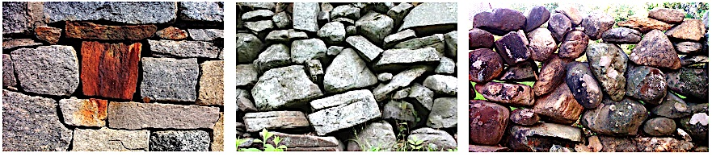

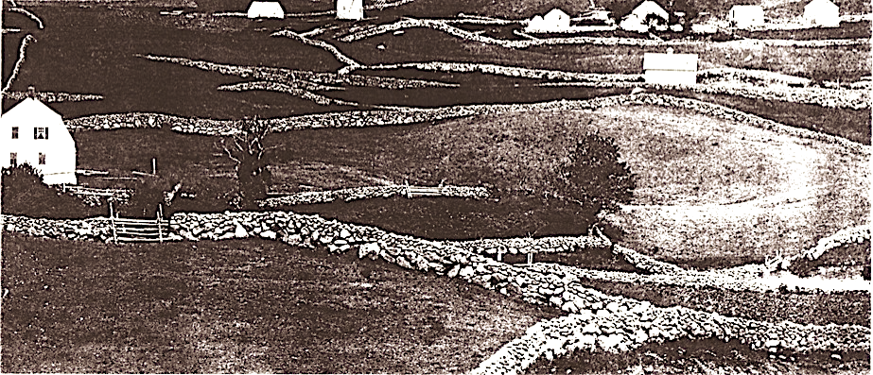

Clockwise from top left: Quarried blocks of granite stained by leaching from a slab of sulfide schist in Storrs, CT. Jagged slabs and blocks of un-coursed Proterozoic gneiss in Guilford CT. Balls and blocks of quartzite from Montauk Point, Long Island, NY. Bottom: View from Beacon Hill, Block Island, RI circa 1880 from an anonymous photo featured by Robert Downie, courtesy of the Blocks Island Historical Society.

Contents

Introduction 3
Background 6
Overview 9
Mapping 13
Spatial Hierarchy 16
Labeling 20
Ground-Truthing 22
Segmentation 23
Measurement 26
Nomenclature 28
Classification 30
Description 36
Dating & Chronology 46
Catalog & Data Entry 52
Analysis & Interpretation 53
Recommendation 58

Author's Note

This working draft is being written for anyone interested in mapping and describing New England's stone walls on the properties they either own or manage. I used the verb tense "being written" because this first draft (Version 1.1) will be updated frequently. I provide it online and free of charge as a work of scholarly engagement from the Stone Wall Initiative at the University of Connecticut. Though my colleagues William Ouimet and Richard Manandhar have contributed to this effort, I alone am responsible the errors and oversights within it. If you quote this, please credit the source. And if you have any comments or corrections, please send them to me so I can rethink and share outward.

Introduction

Purpose

This manual is being created to help any individual or group learn how to define, classify, describe, and interpret the stone walls and related features of New England. It's based on an objective, scientific approach that has been field-tested, peer-reviewed, and vetted by users.

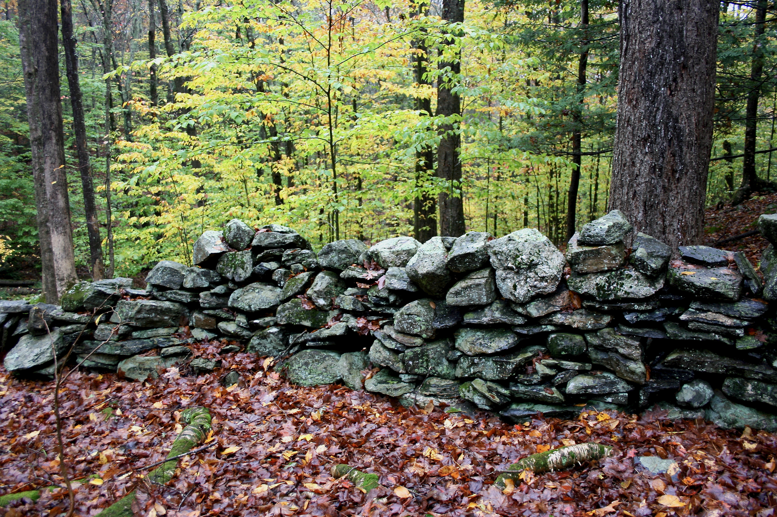

New England's most common kind of wall is a lichen-crusted stack of stone. This classifies as a stacked, one-tiered, thigh- to waist-high, normal single wall containing slab- and tablet-shaped stones of granitic gneiss and schist. A closed canopy forest shades out the undergrowth. UConn Forest, Storrs, CT

I offer step-by-step set of instructions for making an inventory of the stone walls (and related features) on your property to create a rich source of information regarding its history, ecology, and educational value. It's a pathway for really getting to know your walls, rather than merely meeting them once or knowing they exist.

Taking inventory of walls on a property is analogous to taking a census of people in a community because it combines the spatial information of a Geographic Information System map with the standardized descriptions of a catalog. A demographic census reveals interesting patterns of income, political affiliations, purchasing power, ethnicity and education for a group of people. The same thing is true for a community of stone walls. And when the methods for collecting the data are standardized, the results from one place, for example a land trust property in northern Vermont, can be meaningfully aggregated with, and compared to, those of another place, for example a state park in coastal Rhode Island.

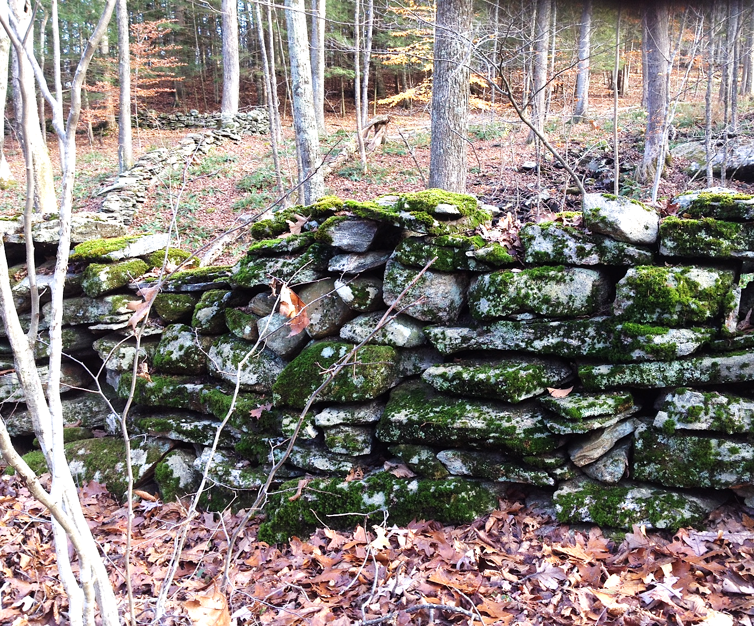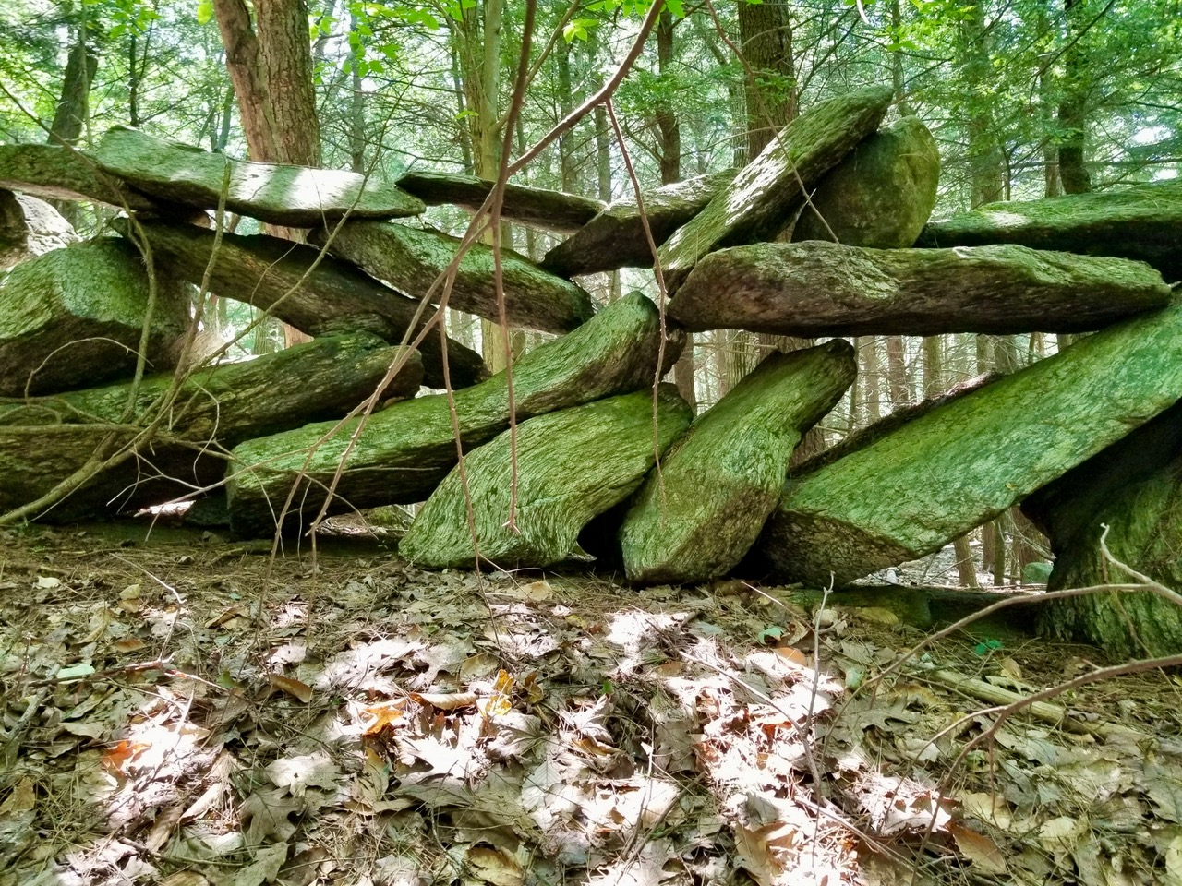

Sample contrasts in New England stone walls. To the left (Storrs, CT), is a carefully laid fieldstone, double wall with one tier and multiple courses, having a mix of stone shapes and compositions, and being heavily covered with moss. It was built as an adjunct to farming operations. To the right (Tyringham, MA in the Berkshires) is a one-tiered lace wall uniformly built of unweathered granite-gneiss slabs, likely idiosyncratic, architectural purposes. Though each wall contributes its own story to local history and ecology, such differences are currently undifferentiated in GIS-based mapping projects.

Your Inventory

The level of effort you devote to a stone wall inventory is open-ended. On one end of the spectrum is visit to a single wall by a single individual who shares that information by talking to someone else. At the other end is a state- or town-funded, comprehensive, systematic, quantitative inventory that culminates in a published report. The key at this initial stage is for a small group of individuals committed to the idea to move forward, propose a project, take that first step, and let your initial efforts slowly improve through time. Future generations will appreciate this.

Speaking of future generations, a stone wall inventory is a great way to engage GenZ the high-school and college-age youth of your town under the leadership of adults who are able to volunteer their time and experience. By convention, members of GenZ were born 1997-2012 and are 13-28 years old in 2025. They might delight in using their cell phones outdoors to locate themselves and visually share what they see.

Using this manual as a guide, a simple walkover will likely be fun, give you a few new ideas, and enhance your appreciation. A detailed inventory will give you a rich new catalog of information and a layer within your organization's Geographic Information System (GIS). To help volunteers get started, I provide a short section titled Overview to give potential volunteers a "heads-up" about what can be done for each subsequent part of the inventory.

Other attributes of your local landscape like the trail network and its wetland ecology are probably already mapped and monitored. Why not do the same for its stone wall archaeology and dryland ecology? The end goal is that your work will have contributed to the creation of a New England-wide story map and searchable catalog.

Why Now?



Sign on Route 14 near the Scotland-Windham town border seeking permission to strip-mine your stone walls in exchange for cash. I was told a similar one was on Route 6 in Hampton. Photo from May 2025.

I was prompted to write this manual in May of 2025 after driving by the sign in the image above. Though the pace of legal strip-mining of stone walls has slowed, we continue to lose these biding threads of our cultural fabric. Hopefully, this manual will help towns characterize their stone wall resources before they are destroyed for future generations.

When I drove by that sign, I was in the midst of a series meetings with representatives of towns, land trusts, and state agencies who are moving forward with a stone wall inventory. These include: Cumberland, Jamestown, and Little Compton in RI; Litchfield, Lyme, Stonington, Sherman, Avon, Ashford, and Eastford CT; and the town of Concord and Quabbin Reservoir in MA. Since then, more groups have asked me to schedule meetings. These three-part gatherings -- usually a roundtable, training walk, and public lecture-- generated questions that I decided to answer in writing to make them publicly available 24/7/365.

Some of the basic ideas within the manual were initially published in my 2005 book Exploring Stone Walls. Others were published in two peer-reviewed scholarly papers: in 2023 for archaeologists and 2024 for public historians. This manual, however, has not been reviewed. I'm sharing it before review hoping that it will help landowners move forward sooner, rather than later.

Background

This manual assumes that you have general understanding of the relict stone walls in New England. The resources suggested below provide the general background needed.

For a broad introduction to the phenomenon from the point of view of a natural scientist, I suggest clicking through the Stone Wall Initiative and my earlier 2005 book Exploring Stone Walls. Though this book is currently out of print, it is widely available from libraries and for online purchase.

For background on the specific attributes of the phenomenon, I suggest the sources below.

Exploring Stone Walls provides a general overview of stone wall study with a focus on description. This was an early (2005) attempt to standardize stone wall science.

Basic history is summarized by my Stone by Stone (or its audio version) or Sermons in Stone by Susan Allport, or The Granite Kiss, by Kevin Gardner.

Aesthetic considerations are illustrated in Good Fences, by photographer William Hubbell.

Ecological considerations are reviewed by Tom Wessels in Forest Forensics,

Management considerations are outlined in my February 2025 article in The Public Historian. This article provides the rationale for conducting an inventory.

Stone Wall Science is presented in user-friendly terms in UConn Today, and detailed in my mini-monograph published in Historical Archaeology. Titled "Taxonomy and Nomenclature for the Stone Domain in New England," it is hereafter referred to in this manual by the acronym TAN.

Stone Wall Mapping using LiDAR is described by NOAA, as applied to New England by Johnson and Ouimet in Anthropocene, and upgraded to machine learning by Suh and Ouimet in GI Science & Remote Sensing. An excellent recent statewide compilation for Rhode Island is provided by the URI Environmental Data Center. New Hampshire has pioneered the citizen-science mapping of stone walls, with nearly 170,000 walls mapped summing to more than 12,000 miles. Though identified and mapped, I understand that most of these walls are not yet ground-truthed and very few have systematic descriptions.

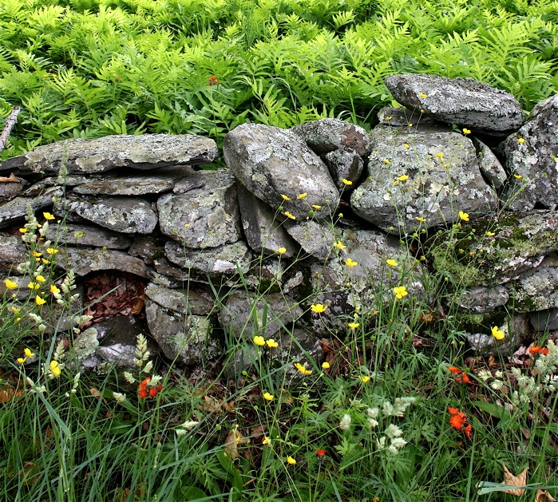

Simple stack of slabs in Holyoke MA reveals how stone walls enrich biodiversity. Where there was once a single habitat of the forest floor, there are now three: the moister, fern-covered upper slope, the grass and herb-covered lower slope, and the lichen-covered stone of the dryland between them, a local desert.

Ceremonial Stone Landscapes, the stone remains of indigenous peoples, as reviewed by the authors in the edited volume Our Hidden Landscapes: Indigenous Stone Ceremonial Sites in Eastern North America, by Lucianne Lavin and Elaine Thomas, 2023.

Chronology and Age-Dating. A recent (2024) review published in the archaeological journal American Antiquity by James Feathers and Shannon Mahan reviews the issues and provides a current assessment for ancient walls in "Luminescence Dating of Stone Structures in the Northeastern United States.

Preliminary Inventory. For the June 4, 2023, annual field trip of the Geological Society of Connecticut, Will Ouimet, Sam Dow, and Robert Thorson, created an unpublished guidebook titled Historic Land Use Legacies in Northeastern Connecticut. Images from the stone wall inventory portion of that guide are included in this manual after slight modification. In turn, this portion of the guidebook was part of a trial inventory project described in a published as a Geological Society of America Abstract. This work remains in preparation for publication.

Several other, more easily accessed articles are also only one click away, notably:
- How Stone Walls Became a Signature Landform of New England in Smithsonian. This essay reinforced the claim that the relict fieldstone walls are the signature landform of New England. A regional inventory is warranted.
- Stone Wall Science by National Public Radio's Academic Minute, claiming that primitive walls nearly built themselves as a consequence of pre-petroleum human ecology. Had petroleum been widely available a century earlier, the majority of walls may not have happened.
- Appreciating and Classifying Stone Walls in The Conversation, describes the need for a standardized nomenclature and classification as the first step toward a science of stone walls.
- A Stepwise, Coordinated Plan for Stone Wall Conversation in UConn Today, which reviews the recent journal article in The Public Historian.

None of the published sources above describe the step-by-step process of conducting a stone wall inventory. The purpose of this manual is to fill that void with a "how-to" manual that can "walk" a novice through a process that we have found to work well and can yield information useful interpretation and management.

Video Tutorials

With the staff at UConn, I'm in the I process of producing a suite of eleven 3–5-minute instructional videos on separate topics having mostly to do with description. These will likely be available by September 2025. For a preview, they are:
1. Introduction - Purpose and description of subsequent videos in the series.

2. Defining a Wall - Pointing out the five defining criteria (material, granularity, elongation, continuous, height.

3. Wall Height - Walls are this high: ankle, knee, thigh, waist, chest, head, >head.

4. Wall Classification - Single, double, broad, band, etc. Domain, class, family, etc.

5. Wall Structure - The vertical presence/absence of tiers, courses, placement, and cross-sectional shape.

6. Wall Segments - Where does one segment begin and another end? How are junctions described? Terminations? Junctions?

7. Stone Terminology - Stones within walls have different shapes, sizes, degrees of order, and sources.

8. Stone Shape - Blocks, slabs, tablets, blades, prisms etc. and rounded equivalents: balls, pillows, disks, dull blades, columns.

9. Stone Size - There are four basic sizes from largest (unmoved) to smallest: Residual, assisted, hefted, one-hander.

10. Stone Order - Dumped, stacked, laid, patterned.

11. Telling the Story - This final video will combine much of the preceding to tell the story of one wall as an example.

Overview

With the Introduction and Background sections behind us, we're now ready to move ahead into the nitty gritty of an inventory & description project. Everything component of it is optional. Anything is better than nothing. Getting started is better than stalling. This section abstracts the steps that lie ahead by reproducing the Table of Contents (TOC) and adding annotations to each item. To see the details, just return to the TOC and click the parts you are interested with at this stage.

Mapping

This section recommends a key initial step -- creating or obtaining a map layer within an ArcGIS (Geographic Information System). Someone from nearly organization engaged with a tract of land has the skills and training to help you. I merely offer an example. The next step is put spatial information about the stone domain into that map layer from the top down using LiDAR and from the bottom up, by importing the coordinates for features already known, like the town pound. You can get started without using GIS by simply using a good, printed map. For example, survey and trail maps often have stone walls mapped. These can be used as a good start.

Spatial Hierarchy

As you map and describe, it's very helpful to understand how spatial information is organized as a hierarchy. For stone walls, the spatial organization starts with the property being investigated. Within that is the Stone Domain, the sum total of historic material culture composed of stone --moved, modified, or made notable. Within that domain are four classes of objects: Walls (continuous, elevated linear features), Concentrations (piles, cairns, and surfaces), Lines (discontinuous or low), and Notable Stones (gravestone, monument, erratic). Below this level are Families, Types, Sub-types, and Variants. This section also introduces the spatial scales involved. the fundamental unit of work is the wall segment. Segments join to form walls, which often surround parcels, which make up districts.

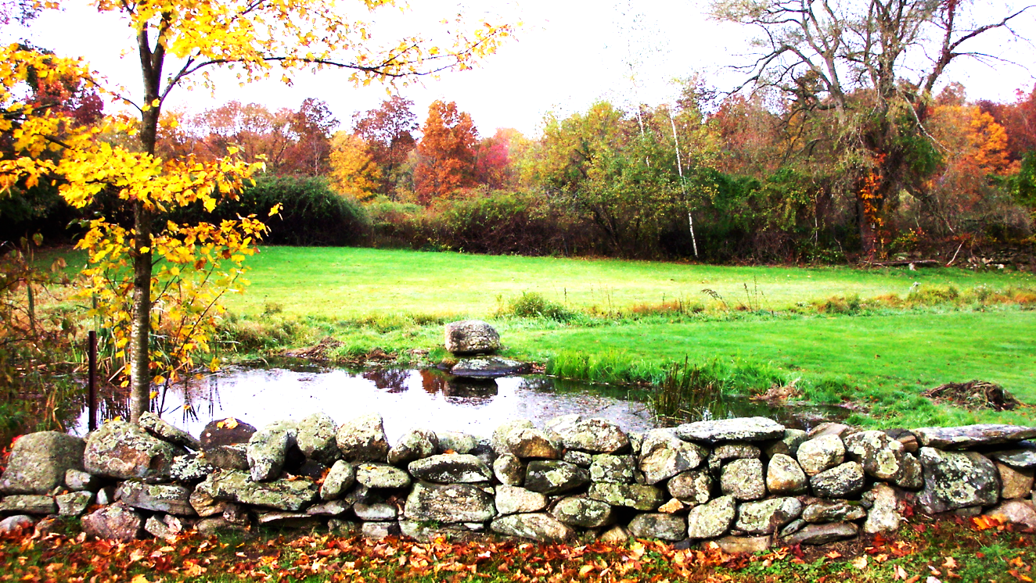

Knee-high, one-tiered, laid, normal single wall in Woodstock, CT composed mostly of blocks, with slabs, balls and tablets of gneiss and quartzite being less common.

Labeling

As you inventory, each segment needs a distinct and unique identifier, as with a person's social security number. Nobody else has the same number. How you label individual segments is up to you, perhaps in the order you inventory them. Because the end goal is land management, we suggest using a labeling sequence associated with a particular parcel of land, for example a yard, field, pasture, garden, etc. In our labeling protocol, the first segment of the first wall of the first parcel is P1W1S1, shortened to 1.1.1. If your project has several districts, you could add an integer for district, for example 1.1.1.1.

Ground-Truthing

Maps of stone walls made by LiDAR or aerial photography are interpretations made either by someone in an office or by a machine-learning algorithm trained to associate linear features with walls. Each identified feature is preliminary until visited on the ground and either verified or rejected. We call this ground truthing. This step of the inventory process identifies the walls to be given subsequent attention. Each will have two terminations at the start and end.

Segmentation

Walls are composed of one or more segments. Segments can't be seen by LiDAR. Nor are they subdivided on even the best of surveyor’s maps. They must be identified in the field by walking the wall in the field and subdividing it wherever there is a gap or a significant change in some attribute (dimensions, shape, type, stone size, degree of order, etc.). The goal is to define the right number of segments to capture major differences, but not so many as to burden the inventory.

Measurement

This part is straightforward. Stones and walls have dimensions of length, width, and height that can be measured. Such measurements are significant. This section lays out a protocol for measurement and suggests tools you might use. Measurement requires knowing the lines (XYZ), planes, and points involved, for example the top, bottom, faces, and cross-sections of segments.

Nomenclature

In science, a nomenclature is a set of terms with clear definitions to facilitate communication and the gathering of data. As such, stone wall science needs a standardized nomenclature. This section introduces that by summarizing the definition of terms and linking you to a concise list within an Excel Spreadsheet. This list has been carefully peer reviewed.

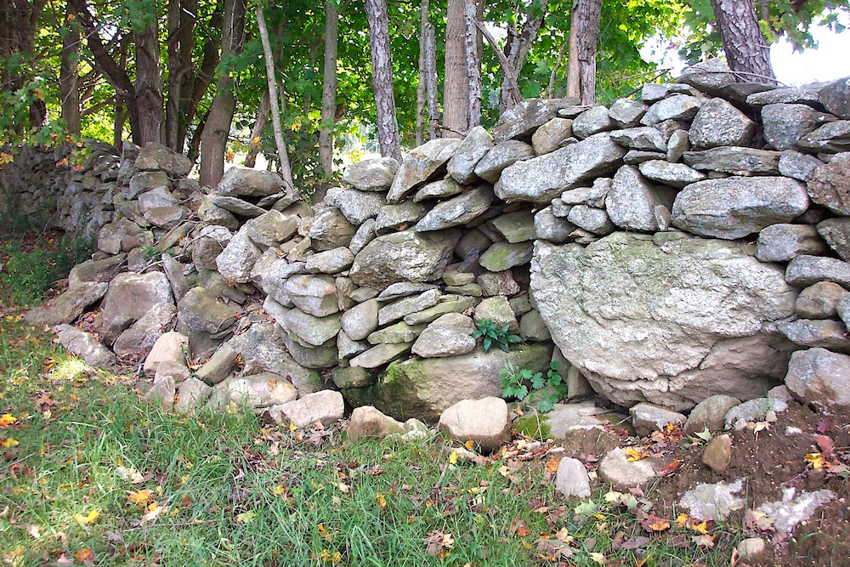

This is one segment of a shoulder-high single wall of stacked stones, with the largest stones at the base. It’s located on some base map and can be assigned a late 19th century age. Data from this wall, when compiled into a catalog and entered into a GIS layer, can tell us much about local history and ecology we did not know before.

Classification

A classification refers to the groupings of other objects. Most --like the genres of music or types of restaurants-- are not rigorous enough for scientific work. That's where a taxonomy comes in. Each is an objective, rule-driven, classification based on yes/no answers to what's commonly called a decision tree. The basic formula is "if this, then that." The key idea is that when you name a specific kind of wall, to simultaneously relate it at higher levels to all walls and relate all walls to all stone features. This section presents the peer-reviewed classification of the stone domain. With practice, it will become easy to use. For example, you are a member of the species Homo sapiens, within the genus Homo, within the family Hominidae, within the order Primate, within the class Mammal within the phylum Chordata. Similarly, the wall shown in this section is a normal single wall, meaning the normal Subtype of the single Type of the family Freestanding, of the class Wall.

Description

This is the most challenging part of the inventory because it's open ended. Your favorite biography might be a 400-page description of one person. Similarly, I could write hundreds of pages about a single stone segment, which would be overkill for any inventory. This section relies on Inventory Entry Forms for walls (Sheet 1) and related features (Sheet 2) of an attached table that can be modified to suit your needs. The key check-the-box descriptions are the kind of wall segment, the dimensions, the way it joins with other segments, the vertical structure of the wall in tiers and courses, and the size, lithology, source, shape, and degree of order (dumped vs. carefully patterned) for the stones. In this section, walls and features are related but kept distinct.

Dating & Chronology

This is the most challenging aspect of wall science to determine because chronological age cannot be seen in the field. Indicators of age, however, can be. In sequence, this section walks you through methods for dating a wall based on: (1) a rule of thumb age associated with deforestation; (2) the calendar ages of documents such as town tax, land, and census records; (3) expectations based on generalized local history; (4) agricultural stages from pioneering to present; and (5) specific concepts and techniques, including rate-dependent chronometric dates. This need not be part of the actual inventory, but is a logical follow-up, usually done in conjunction with a local historian.

Catalog & Data Entry

At the end of the inventory, you will have data and information for each unique segment. This is essentially a catalog similar that those of other professionally cataloged records, for example a library has a catalog of its holdings, as does an art museum. At some point this catalog will be entered into your ArcGIS system so you can see the spatial variation in attributes such as wall type, dimension, or assigned age. How you go about this is very open ended. Though I share the data entry spreadsheet we used to compile our data for one project in 2019, this is merely an example.

Analysis & Interpretation

This Manual for Inventory and Description is about what you can see in the field outdoors. It does not extend to all the methods --statistical and spatial-- that could be used in interpretation. That will be a separate manual, likely written by someone else. What we do offer is a simple preliminary example from the Goss Brook village in Ashford, CT, which we show how variations in segment Height, Taxa, and Degree of Order can vary over the landscape. In turn, we draw some simple interpretations about this variation. The point here is to show you how all your hard work of inventory might pay off for historical, archaeological, and ecological management of these drylands.

Recommendations

Having reviewed the contents and scope of this Manual for the Inventory and Description of Stone Walls, we recommend that you decide the scope of your own inventory project and get started. This is a great opportunity for community engagement, the building of friendships, the spanning of generations, the overlapping commitments between paid staff and volunteers, and, if working on town, state, or federal lands, the building of trust between government and the governed. If the Audubon society can muster volunteers for bird counts, then your organization can do the same for wall counts.

Mapping

Your inventory can start with a blank slate, for example an initial reconnaissance of some parcel of land followed by a short report. But it will be more efficient if you have an identified, mapped population of walls to investigate, each a target for investigation. Hence, this manual assumes you have some sort of base map, and that you are working as an owner, manager, or agency responsible for a plot of land, perhaps a park, town, trust property.

GIS Layer: At the most basic level, you can create or access a discrete ArcGIS (Geographic Information System) layer within your organization's GIS system that is dedicated to the stone domain (historic material culture dominated by walls and other familiar features like cellar holes, cairns, piles, and notable stones). At this stage, the Stone Domain Layer (SDL) is an empty shell waiting to be populated with information.

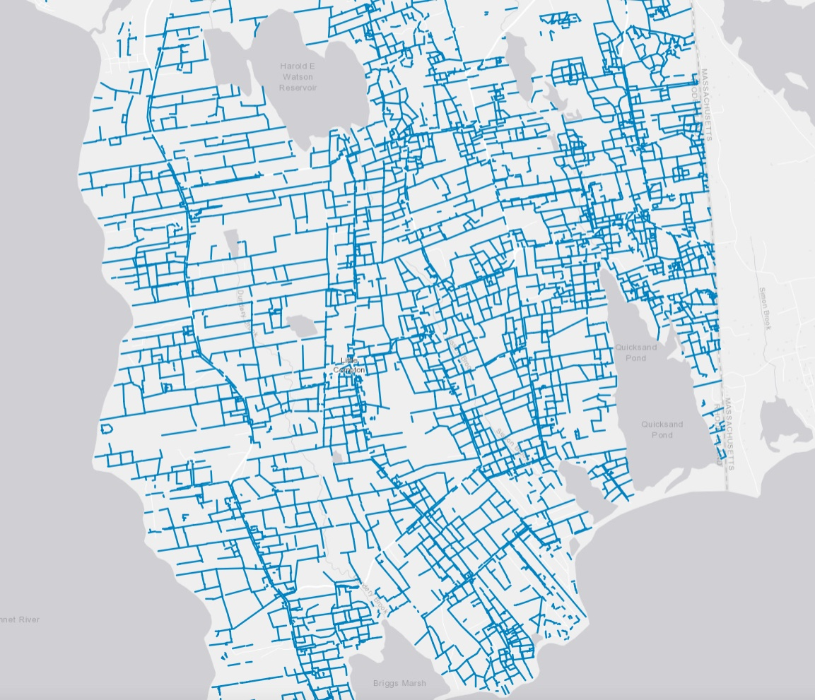

Walls mapped from LiDAR in Little Compton, RI by the URI Environmental Data Center and RIGIS (Rhode Island Geographic Information System), URI environmental Data Center. What is really being mapped here are visible linear features that are plausibly stone walls, subject to ground-truthing, classification, and description. Ground truthing at any scale provides a great opportunity to inventory stone walls to create a catalog that can serve a multitude of purposes.

Top Down: From the top down, the SDL is mapped as linear features detected (eyeball or machine learning) by remote sensing technique called LiDAR (Light Imaging and Ranging). These linear features need to be "ground-truthed" by field visits. In the process, some linear features provisionally mapped as walls will turn out to be other features (road edges, spaced, stone lines, gully edges, fallen trees, etc.). Similarly, some walls will be missed.

Bottom Up: From the bottom up, known historic walls like those around cemeteries or along designated scenic roads can be assigned GPS coordinates and entered directly into the SDL. Such coordinates are easily obtained via cell phones. If your coordinates do not coincide with LiDAR-mapped walls, they should be aligned.

Other: Walls can also be mapped by field reconnaissance, preferably on traverses. This is particularly important in remote areas with a coniferous canopy, which often obscures LiDAR images.

This manual does not cover how to make a map and used a GIS system. Instead, I assume that you have some sort of a map available and expertise to help you work with it.

Example

For an example of LiDAR mapping prior to inventory, I borrow one from the Guidebook described earlier (Ouimet et al, 2023). Our example is of an abandoned village on Goss Brook in Ashford Connecticut. It's identified by the CT Office of State Archaeology (OSA) as site number 3-3, the Trowbridge/Platt Mill Complex from the 18th and 19th century, now owned and operated as a Boy Scout Camp.

We chose this site owing to the diversity of stone walls in both a mill village and the adjacent farmland.

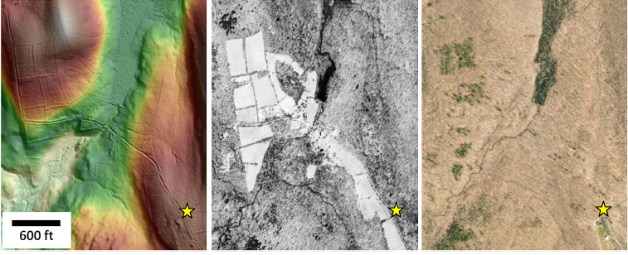

Trowbridge/Platt Mill village on Goss Brook in Ashford Connecticut. From Ouimet et al, 2023. See text below for source and explanation of Right, Center, and Left images, respectively.

Right is the 2016 spring leaf-off aerial image. The dark green is the modern swamp in the site of a former reservoir that drained after the dam supporting that reservoir washed out during a flood.

Center is the 1934 spring leaf-off aerial image, which shows the reservoir partly filled with water as it was nearly a century ago and the farm fields still in active use.

Left is the image seen by LiDAR (Light Detection and Imaging). This is a colorized Digital Elevation Model (DEM) equivalent to a contour map, with white being topographically highest and light green being lowest. The hillside shading from the northwest is added to help see the 3-D topography. Many stone walls are readily visible. The access road coming in from lower right creates local shadows that are sometimes erroneously interpreted as walls. This image also shows the former reservoir, now covered with brush, the road, stone walls as lines, the high hill (white) left of top center, and the lower valley (light green) to lower left.

Building foundations include two large ones with well-preserved center chimney structures, one three-bay barn, a mill building, and several outbuildings. The road from the 18th century is well preserved, including the old bridge footings. The well-built cemetery has extant stones from the 1820s and 1830s. The sawmill, downstream from the reservoir was mapped in 1833, 1856, and 1869.
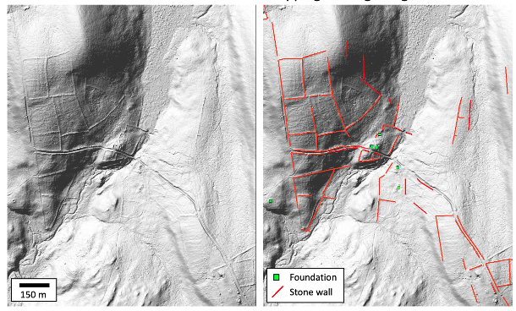

This is the same map area shown above, but with the color-coded elevation contouring removed. To the left is the hillside shaded LiDAR with scale. To the right, stone walls are provisionally mapped in red and foundations in green. When the inventory is done, the individual walls of the foundations will be mapped within the larger population. At this scale, however, they are generalized as green squares.

At this stage, it's important to keep in mind that the red lines in the image above are not walls, but candidate walls for ground-truthing, segmentation, and inventory.

Spatial Hierarchy

Before the inventory proceeds, we need to understand the spatial scales involved.

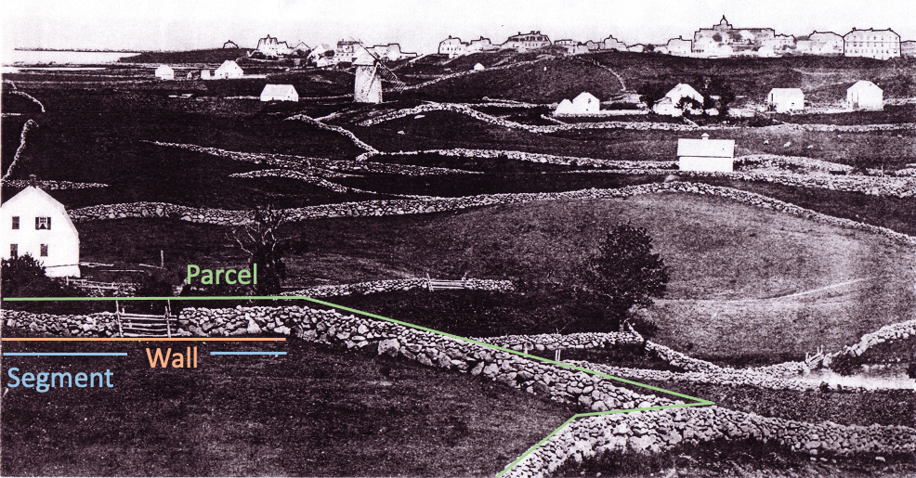

The fundamental unit of stone wall science is the segment, a generally uniform part of a wall. Here, two segments in blue are separated by a gap (barway) filled in with an A-frame of wooden rails. Individual stones sum to segments which sum to walls which often sum to parcels which sum to districts. See cover page for credit.

One Domain

In general, the stone domain consists of "stone walls and related features." Quoting TAN, it's "the subset of outdoor historical material culture composed of stone." The other three domains are wood (the main structural element of barns and houses), fiber (fabric, rope, leather, netting, etc.), and metal (chiefly iron for structural elements, tools, vehicles, etc,), which I leave undefined, and which have generally disappeared unless protected and cared for. In our example from Ashford, only the stone remains.

The all-inclusive stone domain is the subject of our inventory, the sum total of ALL historic objects made of stone, most of which are walls and piles. The word "historic" is a qualifier, meaning that non-historic stone is excluded from the stone domain. In this study area, everything is historic, so this qualifier is not an issue. On properties with modern walls, the qualifier "historic" provides a convenient way to focus on the wall archaeology.

The stone domain also excludes stone emplaced by non-human agencies such as glaciation, talus, or debris flows. There is one important exception. Large glacial erratics, many of which were celebrated as ceremonial objects, have a human element, even though they were "naturally" emplaced. Evidence of that humans considered such stones notable is often present as markings or plaques.

Beyond stone walls, the stone domain also includes related important objects like cellar holes, flagstone pathways, monuments, gravestones, root cellars, and notable stones. These are called "Features." To inventory walls without including them would give an incomplete picture at best. This manual focusses on walls first and returns to features later. Each has a separate data entry form.

Four Classes

The stone domain consists of four classes, the most salient of which is the class Stone Wall. To be considered a wall, the stone object must meet five criteria: In material, it's made of stone, natural or synthetic. It's granular, meaning the wall must consist of many stones, rather than being a large slab of rock. It must be continuous, meaning not dotted or dashed, and it must be elongated,
meaning it must be four or more times longer than wide at grade. Finally, it must meet the height requirement, either by stones resting on other stones or being approximately knee high, an arbitrary height that makes it a barrier because it can't be stepped over.

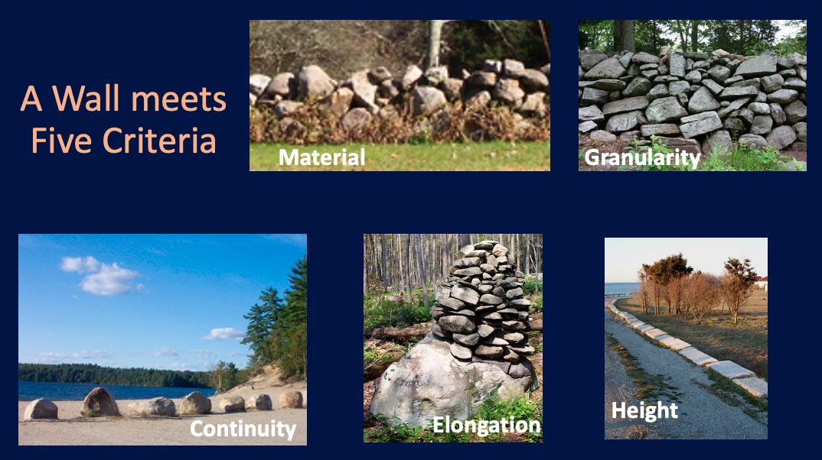

Normally, the existence of a wall is self-evident. But in many cases, a wall must be verified by meeting all five criteria. The three lower photos show a line defined by lack of continuity, a concentration defined by lack of elongation, and a line defined by lack of height.

In addition to this scientific definition, there are also vernacular, local, and legal definitions. Only the scientific one is rigorous enough for an inventory because in the rest, different names are used for the same thing. For example, the definition of a stone wall in Connecticut requires that they be vertical uprights and have a consistent pattern of stone type. Technically, this rules out most stone walls because walls on slopes cannot be "vertical" when looking at the face of the wall. And "type" refers to a multiplicity of attributes (size, shape, composition, source, etc.), only some of which may be consistent.

The good news is that in the vast majority of cases, you don't need to define stone Walls because they are self-evident. The scientific definition above is used at the taxonomic level "class" mainly to exclude Lines, which are either not continuous or not high enough; Concentrations, which are not elongated, and Notable Stones, which are not granular, as in the case of a gravestone, celebrated erratic, or solitary post. For additional details of the classification, refer to TAN.

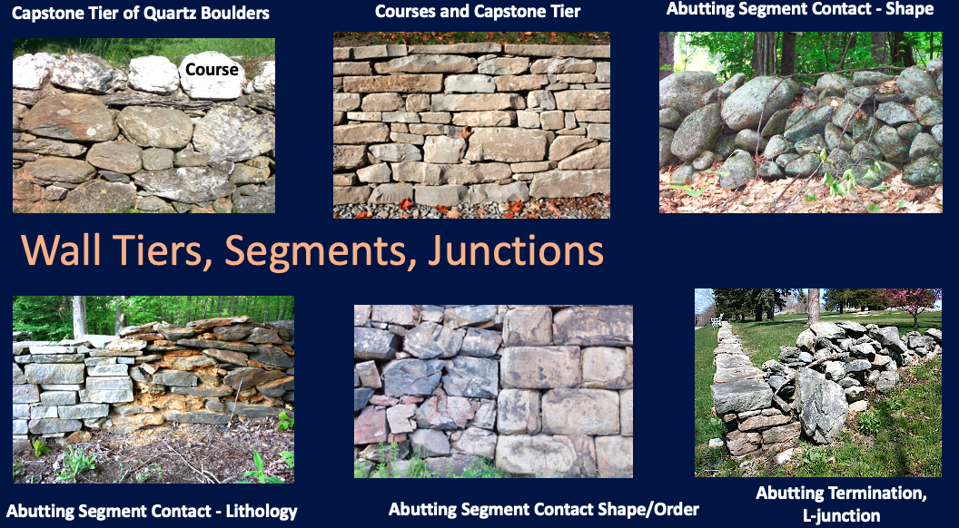

Terminology for Wall Structure with 3 examples of segmentation. TAN shows many additional images.

Walls begin and end with terminations. There beginnings and endings of walls are two basic types:
- Tips: Walls end without junctioning with another wall. These may be built tips, in which case the stone is stacked or laid to a stronger discrete end, or unbuilt tips, where a band ends or where a higher wall becomes lower until it's gone.
- Junctions: Walls often end by junctioning with another wall, typically either with terminations that are either abutting (a distinct line from top to bottom separates them) or woven (stones from both walls overlap each other) junctions. Common spatial patterns are L, T, X and Y junctions. An L junction jogs left or right, depending on the mapping direction. T junctions are common. A sharp curve >45 degrees in an otherwise straight or broadly curving wall constitutes a rounded corner. These usually have woven termination.

Wall Segments

A stone wall consists of one or more segments occurring along the line of the wall. This makes the segment the fundamental unit, akin to the cell in biology. A segment is an unbroken portion of a wall that looks more or less the same (subjectively), regardless of length, and which does not junction with another wall. For example, one part of a continuously uninterrupted wall may have dominantly jagged stones and the other mainly rounded ones. Part of a wall may have quarried stone, whereas another part has none. Or part capstones and part not.

The boundary between one segment and another is called a contact. Gaps, a common form of contacts, occur on opposite sides of a break in the wall, often a barway. Alternatively, contacts can occur within un-gapped walls to highlight differences. These ungapped contacts can be abrupt, abutting, transitional, interwoven, etc. One of the biggest challenges in doing an inventory is deciding when to end one segment and to begin another.

Parcels

Walls can occur in isolation. Normally, they junction with other walls, usually close to right angles to form parcels, meaning a land area bounded by walls on two or more sides. If only two walls are present, the parcel is assumed to have the other two sides of the same length and width. A parcel is not part of the stone domain because it's not made of stone, but it is a useful term for inventory purposes because it's a way to group stone walls into larger features.

District

Stones aggregate into segments. Segments aggregate into walls. Walls aggregate into Parcels, often in a checkerboard or fractal pattern. In turn, parcels aggregate into something larger. What should we call this larger space consisting of many parcels? My default term is district, which connotes a localized geographic space. This may or may not coincide with the entity being mapped, whether a land trust property, a town park, or a U.S. National Park like Acadia, which has many walls.

Labeling

Having the hierarchy behind us, we can now turn our attention to the labeling of mapped walls prior to inventory. To go into the field without a list of target walls and segments is inefficient, especially when you have more than one person or one group mapping in different places.

At the same time, we must keep in mind that mapping the walls from LiDAR is preliminary, as the subsequent ground truthing will likely reveal that some mapped walls are false positives (Type 1 error: they are mapped, but not there) and others are false negatives (Type 2 error: they are not mapped but are actually there).

Only after such ground truthing can a wall as a catalog entry be officially labeled. This can be done in a way that best fits your project. For example, you could label them chronologically in the order you investigate them by year, date, and hour. Or you could label them in sequence from the first one mapped to the last one regardless of when this occurred.
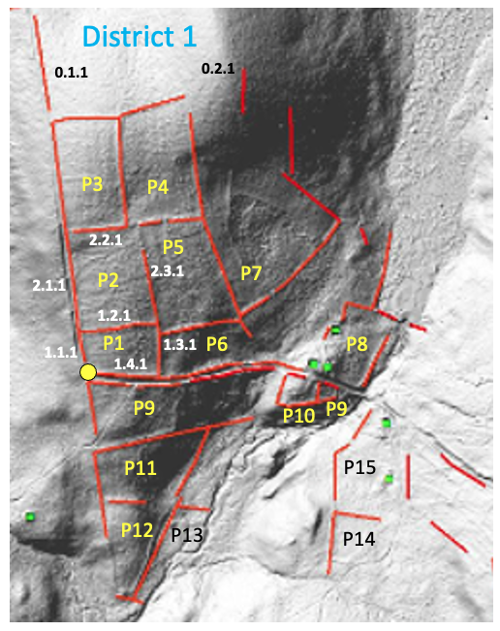

Sample Labeling Protocol for the abandoned village on Goss Brook in Ashford, CT described earlier. Hierarchically, the District contains Parcels, which contain Walls, which contain Segments, not shown.

We have learned through experience that the provisional labeling walls works best using the hierarchy because, the parcel (e.g., a named former field or pasture) provides the most historically meaningful frame of reference. Down the road, this will allow the interpreter to describe, for example, the "north wall of the old calf pasture," relative to the three others. In the illustration above The LiDAR mapping (shown in red in the example above) shows an example. Where you start is up to you. In this case, I chose to start at the yellow dot, the southwest corner of the parcel bounded by the road on two sides. On this figure, I label:

Districts, or study areas within your project area identified in blue text. There is only District 1.

Parcels within Districts, which are polygons defined by two or more walls (preliminary identifications by LiDAR) with corners between them. In District 1, I identified 15 parcels, labeling them P1 through P12 in yellow text and P13-15 in black text because the yellow didn't show. Technically, these parcels are polygons, but I chose not to use this term because it means something different in GIS. Parcels are helpful because it becomes easier to talk about how the walls in one field pasture (parcel) are similar or different.

Walls surrounding parcels occur on two to four sides, and along single lines. In this image, there are approximately 50 walls. Starting at datum, and following a north direction, the first segment of wall is labeled 1.1.1. This is short for Parcel 1, Wall 1, Segment 1, or P1W1S1. Later, when on the ground, you will likely find additional segments for this wall, labeling them in sequence 1.1.1, 1.1.2, and 1.1.3, etc. for a 3-segment wall. This wall ends at the T-junction corner where the direction of mapping turns right. This is where Wall 2 begins its first segment 1.2.1. Turning the corner again in the same parcel gives us wall 1.3.1, and again gives us 1.4.1 to complete the square.

Note that when we move ahead to Parcel 2, its south side is the same wall as the north side of Parcel 1. My recommendation is to record this as a fourth wall in parcel 2 (2.4.1) that refers back to 1.2.1. There is no need for description because you've already done so. I call such walls "mirror" walls.

Within this district, eight or nine walls are un-junctioned, meaning they will have tips, and are not yet part of parcels. These I designate using a zero "0" for the parcels. For example, the first segment of the most northwesterly wall in the figure is 0.1.1, which means Parcel 0, Wall 1, and Segment 1.

Segments within walls. Segments can't be mapped from LiDAR because some can be very short. Recall that the number of wall segments is un-determined prior to ground truthing. They are determined by walking the wall, deciding on how many segments there are, and labeling them accordingly.

Recall that the label for each segment will later be used to tag documentary photos and objective descriptions (taxon, stone size, stone shape, etc.). Though it's critical to keep track of them for the catalog, the final map interpretations need not show them, as in our examples near the end of this manual. Giving walls and segments local familiar names may help with storytelling and interpretation, for example the "old boundary wall."

Ground-Truthing

With your map in hand and your preliminary list of walls to inventory, you are now ready for work on the ground. If you opted to follow my suggestion, each target wall has a labeled sheet in a clipboard or digital tablet screen. This section follows the posted Excel file called Wall Entry Form.

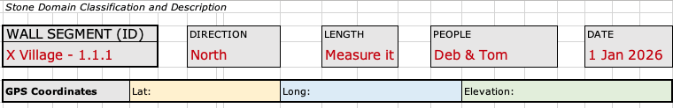

Top of Wall Entry Form suggested for stone wall inventory. See text for explanation. Similar clippings from the form will not be labeled as separate figures.

On the top of the Wall Entry Form, the segment is labeled XVillage-1.1.1. It's Segment 1 of Wall 1 of Parcel 1 in District X, referred to as X Village. Its Length can be measured in the field or added from GPS or field data, preferably in the case of a long wall. The Direction matters because segments accrue in that direction and there is a left and right side of every wall. The Date is a typical convention for many forms. The same is true for People, those who did the inventory.

Immediately below the segment identification heading is a row for the GPS coordinates. This can be entered prior to field mapping from the LiDAR map to send crews to the right points. Or it can be left blank to fill out later. In either case, it's good to have the coordinates in the catalog as well as on the GPS map in order to prevent mix-ups. And it's a good idea to record the coordinates in the field with a hand-help GPS unit as well (your phone can do this.)

During our examination of the Goss Brook village, we found several false positives for walls identified from LiDAR but which were not found on the ground. These were shadows along road cuts, locally elevated soils, and fence-line accumulation of dirt or buried stone. We mapped 40 segments ranging from 7 meters to 172 meters in length.

Segmentation

At the beginning of field work, I strongly suggest that you walk the entire wall to get a sense of its uniformity or variability before you begin the process of segmentation. The goal at this stage is not to describe the segments, but merely to identify them. With experience, it's more efficient to do the descriptions as you segment the walls.

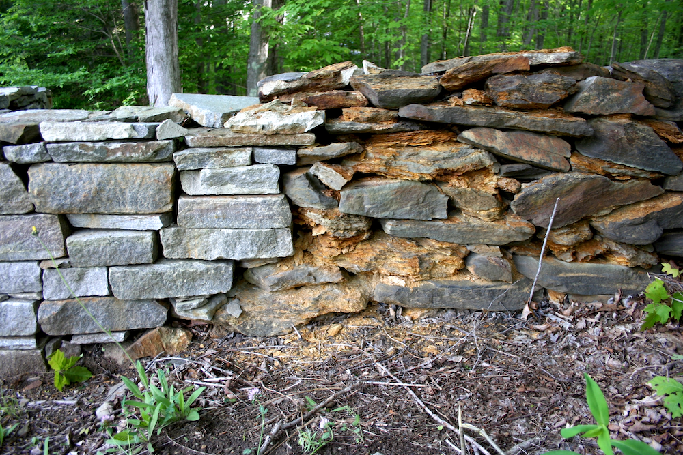

One wall with two segments with an abutting (sharp) contact. To the right is a segment of laid double wall built in the 1960s with quarried stone from the Brimfield Schist, which, contains high quantities the iron sulfide mineral pyrrhotite (related to pyrite) that rapidly rusts, causing failure. To the left is a segment built in the 2000s with quarried slabs and tablets of granite. If this wall were not differentiated into segments, this history would be either lost or garbled.

Deciding what constitutes a new segment within a wall is a matter of judgment. But each bounded either by a termination at the end of a wall or a contact within a wall. Technically, every linear meter of the wall is different. Hence, differentiating segments requires a subjective tradeoff to get the most useful number of segments. Differentiating too few generalizes the description and history. Differentiating too many creates extra work and obscures the major differences. Keep in mind that segments can always be combined after field work, but not after it.

Gaps: The simplest contact is a gapped contact, called a gap in which stone is absent from top to bottom, with the possible exception of a few basal stones still on the ground. Walls on opposite sides of barways are, by definition, different segments. If the upper part of the wall is merely toppled or collapsed by gravitational failure, but the line of stone continues near the base, this does not constitute a gap. Rather, it is a collapsed portion of a segment. However, if this collapsed portion of a segment is long enough, you may wish to designate it as a separate segment. Judgment calls are needed.

Many gaps in New England walls were created during post-farm logging operations when the front blade of a skidder/bulldozer/loader was driven into a wall, causing it to be pushed over from bottom to top. The direction of push can usually be determined by what I call a flap on both sides of an unbuilt segment tip. This is a mass of fallen stone that dribbles away to invisibility with increasing distance from the source wall. This is a vital clue to the history of land use because it almost always indicates 19th century disturbance using petroleum power. And the direction of a flap (left or right relative to mapping direction) informs the direction of movement. For this reason, I include flaps as a box-check on the field form.

Bend. This is used when a wall makes a distinct bend sharper (at least several degrees) between two linear segments or on a broader continuous curvature.

Abutting. If one segment is built against another, as with the figure above, it is an abutting contact. Most abutting contacts are vertical, though this example is irregular.

Woven. The materials from one segment may be interwoven (or selvage) with those of the adjacent one. This usually indicates a deliberate subsequent effort to extend a wall while keeping it strong, or to de-emphasize the contrast.

Gradational. At the meter scale or larger, the properties of the wall may show a transition, for example, in shape from balls to blocks, in size from hefted to assisted, in lithology from granite to limestone, and in structure from double to single, etc. This will be a judgment call.

As this stage, the on-the-ground inventory of segments and walls is complete. Consider this the first draft of the catalog: the searchable data base to follow for walls segments or features.

Each catalog entry for a wall or related feature will contain these key aspects: a
- Unique identifying label, for example P3W2S1 for the first segment of the second wall in the third parcel.
- Classification name revealing what kind of feature it is, for example Normal Double Wall.
- Documentary photos following a common protocol, for example: Photo 1 looking down the line of the segment, Photo 2 looking at a representative face of the wall, and Photo 3 looking at the termination of the wall or the end of a segment.
- Standardized description for the purposes of documentation and comparison, informed by a separate section of this manual, and
- The mapped location, a line in the case of a wall segment, and points in the case of features and wall terminations.

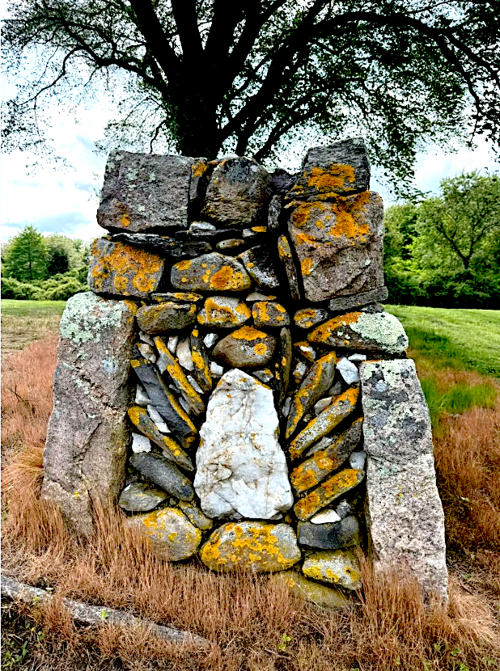

Patterned degree of order qualifies as folk art. This is the YZ plane of a built tip (termination) of a two-tiered double wall in Narragansett, RI. It's attributed to local builder Craig A "Little Fox" by Eric J. Dolin who posted this photo on social media prior to it being forwarded to me by a third party. So, I assume that it's in the public domain. I include it to celebrate the folk-art tradition of indigenous builders, and to feature the "patterned" degree of order that goes beyond being merely a "laid" degree of order.

Digital photos provide an easy way to document wall segments. The sky is the limit. Take as many as you like. I suggest a that a minimum of three photos be taken for every segment: (1) of the top extending from near to far down the in the line of the segment, and (2) of a representative face of the segment in the profile (or elevation or longitudinal) view; and (3) one or more ends of segment where it forms a tip, gap, junction, or contact. At the bottom of the Field Form is a box for labeling-linking the photos to the segment.

Measurement

Walls and stones also require a measurement protocol, as shown below. This technical illustration looks worse than it actually is because, once learned, it's nearly automatic.

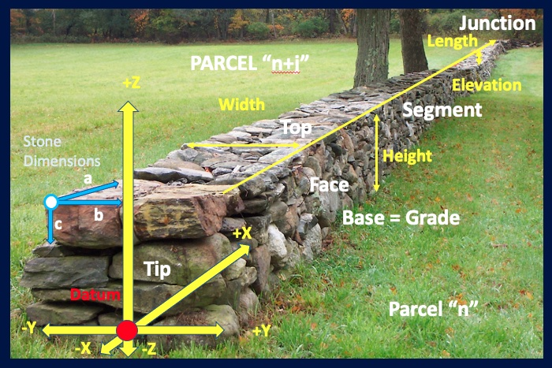

Terminology and coordinate system for wall and stone measurement. In the foreground is the built tip of the first segment of a normal (subtype) double (type) freestanding (family) wall (class) of the stone domain (domain). The segment ends at the other termination, a J-R junction, barely visible in the background.

For measurement of heights and widths, the tool I use in the field is a metric surveying rod 3 meters long and graduated in meters, decimeters, and centimeters. You can easily make one from any pole ( I use PVC piping marked off by colored electrical tape). You may prefer to measure in feet and inches. That's no problem because these can be easily converted after the inventory. For lengths, I use a rangefinder or long tape, both of which are available in hardware stores.

Stones

Shown in blue on the diagram above, each stone has a long axis length designated by a, an intermediate axis width designated by b, and a short axis or thickness, designated by c. These axes define three planes: the ab or AB plane is the surface area of length and width; the ac or AC plane as the longitudinal section or, in architectural terms, the elevation view, and the bc or BC plane designated as the cross section. I strongly recommend measuring in the metric system, which can easily be converted back to the feet and inches of the more archaic, but more familiar, English system of measurements.

Stones are irregular in shape. Note that on many stones, maximum length may not be perpendicular to maximum width and(or) thickness. But for efficiency, we will ignore this problem and imagine that these dimensions are indeed orthogonal (perpendicular in two other dimensions) on the stone in question. An easy way to do this is to imagine the stone inside of a tight-fitting cardboard box (where the planes are orthogonal), with your measurements being on the cardboard.

On the Wall Entry Form the inclusion of measured stone dimensions is optional because this is crudely (but efficiently) incorporated into the general size categories of one-handers, hefted, and assisted. The actual measured dimensions matter less than if and how they were moved. However, if you have time, any measurements you make will be helpful, especially of the maximum lengths.

If you are going to make measurements of stones, the salient attributes are maximum length, which explains itself, and the D₈₄. This is a term borrowed from sedimentology used to characterize samples of sediment grains (which the stones of walls are). Begin by imagining the range of particle sizes from minimum to maximum, from small one-handers to meter-sized assisted stones. Now identify in your mind the 84th percentile in size (80 percent is close enough) that focuses on generally the largest stones. The largest stone is captured in a separate category.

Walls

DATUM: Each wall also has a coordinate system. Datum for these orthogonal lines is the center of the tip of the wall at grade (land surface). From datum, the line X is the line of the wall, forward as +X and reverse as -X. The width is Y, with +Y to the right and -Y to the left. The height is Z. Buried portions of a wall are in the -Z direction.

PLANES: The face of the wall is a plane in XZ. The end of the wall is a plane in YZ, especially in a built tip. For a wall that ends on a taper from full height to a single stone, the end is the size of the final stone. The surface area of the wall is a plane in XY, either at the top or the base of the wall.

Planes are self-evident on a well-built wall. For a crude single wall, the base is self-evident. The top is equivalent to a thick line with the width being the average width of the top row of stones.

LINES: The height of a wall is a line from base to top. On a horizontal surface, this is vertical. on a sloping surface, it's orthogonal (perpendicular in two directions) to the slope. On flat, well-drained ground, freestanding walls have generally equal heights. On slopes, there are often two heights, one on the uphill side that has been shortened by the accumulation of soil creep (colluvium), and the down hillside that has been lengthened by erosion of soil. On the face of either side, there will be a maximum, minimum, and median height. The width of a wall is a horizontal line extending from one face to another. There are usually two widths, one each at the top and bottom of the wall. There will be a maximum, minimum and median height.

Except in vertical or overhanging cases, the base of the wall is larger than the top, making them trapezoidal in shape. The only vertical part of the wall is its unseen midpoint bisector.

The section above does not apply to flanking walls, which have only one face. There is only one height, and one top width (usually a single stone), but the base of the wall is invisible, meaning widths cannot be measured, or are undefined.

Nomenclature

In order to classify and describe the structure of stone walls and the characteristic of the stones, we need to agree to some basic terminology. This I outlined in Table 1 of TAN, reproduced below as an illustration.

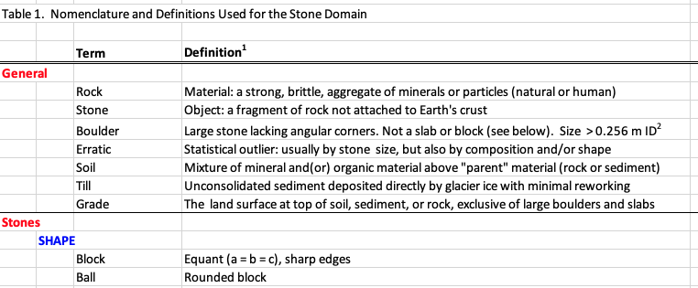

Screenshot of Table 1 of TAN, made available as an Excel Spreadsheet SWI Inventory NOMENCLATURE.

To understand this, please review the entire table and examine the many photos and descriptions within TAN.

I start with two general ideas:
- Stone is an object made from the material rock.
- Grade is the land surface at the base of the wall, the top of the soil.

Descriptions of Stone:
- Shape is defined by estimating the equality or inequality of ABC (length, width, thickness) and whether the jagged, sharp, or angular corners of the original rock fragments have been rounded. For example, blocks and balls are equant because length, width, and thickness are equal, and therefore undefined. A blade is the most inequant, with length greatly exceeding width, which greatly exceeds thickness.
- Size is scaled to the human lifting strength, rising from One-handers to Hefted stones. Assisted stones are moved with assistance. Residual stones were too big to move in one piece. Rubble (angular) and gravel (rounded) are often part of the fill of a double wall.
- Source comes from three places: the local adjacent land surface (Field), rock outcrops that were quarried by humans regardless of distance (Quarry), and excavations of unconsolidated material, usually gravel pits (Pit).
- Order refers to the degree of order of the arrangement, ranging from disordered (Dumped) to merely stacked (Stacked). In contrast, the degree Laid is when the walls are carefully assembled into courses or the stones tightly fitted together to minimize pore space. This is masonry, in which the positioning of one stone greatly influences the positioning of the next. The highest degree of order is Patterned. Some elements of style or art such as decorations or mosaics go beyond that of what is usually a laid wall.

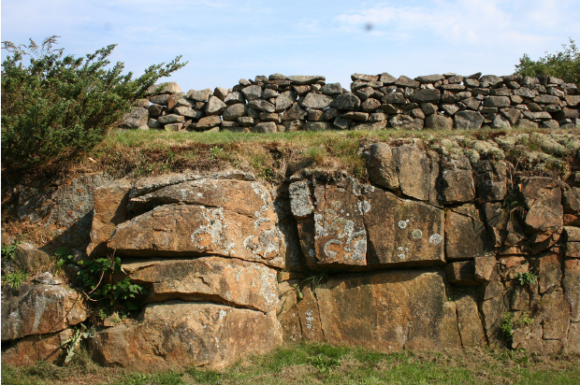

Rock is the material of the Earth's crust. Stone is an object made from that material. The vast majority of stones in New England, whether in walls or on the land between them, were: (1) torn (quarried) from bedrock ledges and other outcrops at the base of the Laurentide Ice Sheet between 30,000 and 15,000 years ago, (2) modified during transport, usually by being broken into smaller sizes and having their corners milled into a rounded shape, (3) scattered widely across the landscape surface, (4) buried by postglacial soils, and (5) re-concentrated back on the surface during the agricultural makeover. Kennebunkport, ME.

Descriptions of Walls (See Presentation slides, which are illustrations with dark blue backgrounds)
- Tiers refer to vertical (+Z) zonation within a wall. Simplest is a one-tiered wall with similar stones from bottom to top. Common are two-tiered walls with a crude foundation tier of large (assisted) stones, a main tier of fieldstones (hefted). Rare are three-tiered walls (or more) with the foundation and main tiers capped with a third tier of larger, flatter, sometimes quarried capstones.

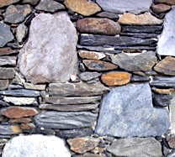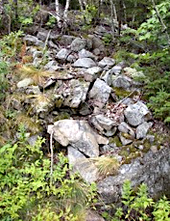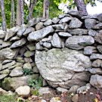

Left to right: Patterned degree of order that is above and beyond a laid degree of order. Cliff Walk, RI. Dumped degree of order in a stone band, Weld, ME. Stacked degree of order in Hebron, CT.

- Courses refer to the horizontal layering within walls, which is most common with tablet- and slab-shaped stones, and least common with blocks and balls. A brick wall usually has one tier with many courses.
- Shapes refer to overall exterior geometry of the wall, most commonly crudely triangular, commonly trapezoidal, asymmetrical, or merely mounded.
- Dimensions refer to the height, width, and length of walls and segments, ranging from sprawling ankle-high bands to tall stone fences.
- Matrix refers to the material filling the pore spaces in the stones, usually air. Drystone refers to having no mortar. Mortared refers to a cement matrix, which may be interior and hidden or exterior and plain to see. Hearting is rubble and gravel used to fill spaces in double walls. A filled matrix is one where the air is displaced by soil, peat, or water.
- Preservation refers to the general degree of modification from the original condition of a new wall. Three key elements are the degree to which the wall is: Covered with lichens, moss, algae, and staining from weathering; tumbled from the top down (Topple); or fallen apart from subsidence or tree roots (Collapse).
- Terrain refers to the location of walls relative to four general settings: Freely drained Upland settings with firm soils, poorly drained Lowland settings with soft soils, usually wetlands, Rocky settings on bedrock outcrops, and the Streambed settings of flowing or ephemeral streams.

Classification

The single-most important thing to observe is what kind of wall segment you're looking at. By kind, I mean the name or label it's given within a classification, in this case the taxon in a taxonomy, which is an objective, rule-driven classification based on yes/no answers. After years of trial and error, and finding no useful precedent, I worked with hundreds of New England residents, many colleague, and the anonymous reviewers to create the simplest taxonomy I could that was able to include all aspects of the stone domain, with special attention to stone walls.

Taxonomy

The taxonomy was published in Historical Archaeology as Table 2 in TAN. I suggest you download it as an Excel Spreadsheet with the file name SWI Inventory-TAXONOMY-Table 2 TAN. The top part of this table is reproduced below. For those with institutional access to Springer Journals, it is also presented in the form of a decision tree that could be rendered into an app in Supplementary Materials.

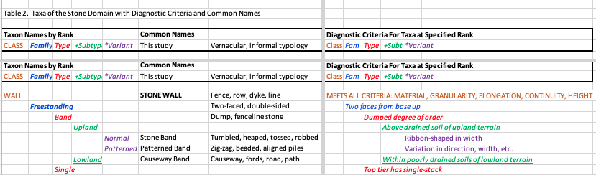

Screenshot of top part of published table 2 of TAN, shared as a spreadsheet SWI Inventory-TAXONOMY Note how the diagnostic criteria to the right lead you to the taxa on the left. The text walks you through the decision tree.

To speed up classification in the field, the names of taxa by rank are reproduced in the FIELD FORMS. These data entry forms can be printed from the Excel Spreadsheet SWI Inventory-INVENTORY FORMS, with Sheet 1 for Walls and Sheet 2 for Features. All you need to do to classify a wall or a feature is to check the correct box.

The columns of TAXONOMY are grouped under three main categories. To the left are the Taxon names by Rank nested within one another at different hierarchical levels (CLASS, Family, Type, +Subtype, and *Variant). On the table and in the text, I color code the rank to make it easier to follow. The next main category of the Table, Common Names, contains the common name I use to refer to the taxon and the informal or vernacular terminology often used as a synonym. The third main category includes the Diagnostic Criteria for Taxa at Specified Rank for each dichotomous choice. These are color coded. This is effectively a decision tree that is expanded and clarified in TAN's supplementary materials, and awaits development into an App.

If the wall you're investigating borders on a stone line by being discontinuous, or a stone concentration by not being elongated enough, confirm that it's indeed a wall before continuing with this part of the manual. For example, primitive walls known as stone bands shorten into piles or become discontinuous into concentrations.

Freestanding Walls

The text below moves from most common wall to least common, based on my decades of experience. The discussion of hybrid walls, those built above or alongside previous walls, ends the section.

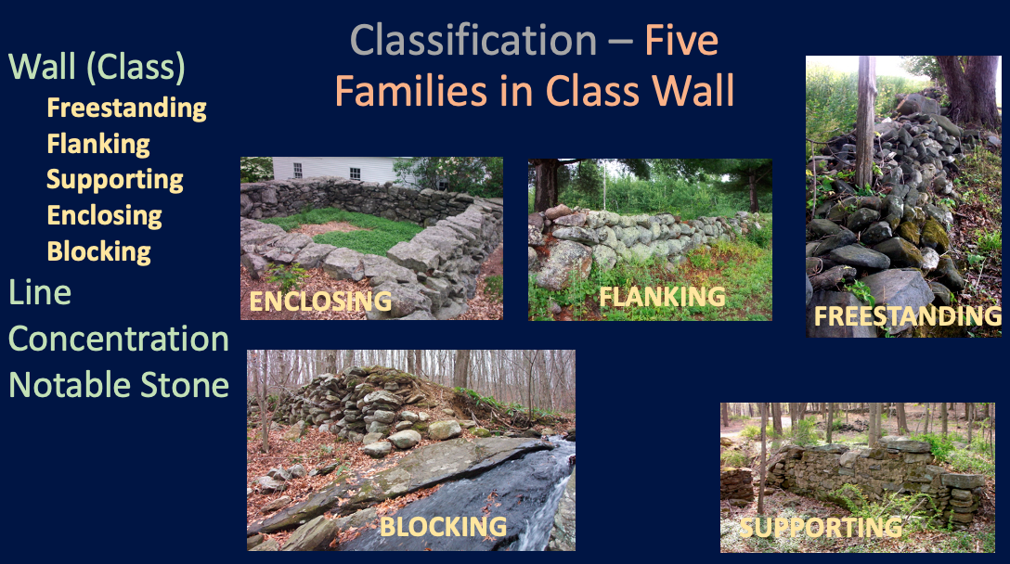

Examples of all five Families in the class Wall. Clockwise: Town pound, retaining wall, stone band, mill dam, and cellar wall.

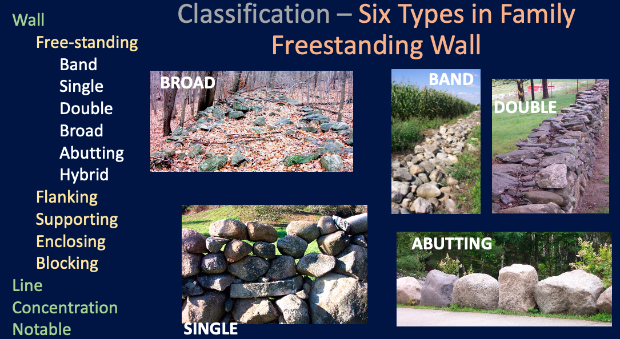

Examples of the five main types of Freestanding Walls. Hybrid walls are discussed elsewhere.

If your wall has two sides (or faces) it's a Freestanding wall, which is by far the most common wall in New England. Now you know what family it's in.

The most common type of freestanding wall is the type Single wall, which usually has a crudely triangular shape culminating in a single layer of stones along the top of the wall. This describes the Normal subtype of the single wall. If the upper part of your single wall has a tier of stones that rise as a panel of single stones stacked one above the other and extending to both sides, it's called the Panel subtype. This usually indicates a subsequent addition to an earlier, lower wall. Most true fences are panel single walls. Panel walls can be either the variant Open, when there's so much pore space it's easy to see through the wall, or Fitted, when the stones are arranged to minimize pore space.

Next most common is the type Double Wall. These are defined as a wall built from both sides with the sides leaning inward against each other to provide structural support, stabilizing the feature. In the subtype Normal, the top of the wall exposes the stones slanting inward from both sides, often with some rubble or smaller stones in the middle. In the subtype Capped, the double wall usually capped with a single layer of stones that spans both sides, strengthening the arrangement. In New England, this layer almost always consists of larger stones laid flat with their AB (length/width) planes horizontal to create the Capstone variant. In rare cases, the upper course of stones is arranged with their AB planes vertical or uniformly slanting. This is the Copestone variant.

Stone Band. Unusually straight-edged, slightly mounded, stone band defined as a wall (class) because stones rest on stone, freestanding (family) because it has two sides, and band (type) because it is low and dumped. Most bands are more sprawling and irregular. This is not a broad wall because it's not built on the sides.

Less common is the type Broad Wall. This is essentially a double wall wider than necessary for structural support; essentially separate wall faces built up to 20 feet apart and with the center filled with dumped stone. On upland ground, this is the subtype Normal, built mainly as a capital improvement project to dispose of excess waste stone. In the lowland terrain of swamps and small streams, this is also the structure for primitive causeways and bridges, which serve the additional purpose of transportation. The subtype here is Lowland, most of which have primitive conduits, many collapsed.

Slightly more common are the type Stone Bands. The key criteria are that concentrations of stones are low and merely dumped, rather than stacked or built. In the subtype Upland, the Normal variant is little more than a low continuous band often linked to low single walls. The Patterned variant is when the bands exhibit spatial variation, such as following a zig-zag pattern beneath a former split rail fence, or a beaded pattern of widening and narrowing as dumped loads of stone. In the subtype Lowland, bands of dumped stone extend across wetlands as primitive causeways.

The final type of Freestanding wall is the Abutting Wall. These are large stones pushed together to create a continuous line of stone that meet the height criteria for a wall. Most of these are 20th century, petroleum-powered walls. The subtype Equant is for stones that have an equant shape, either as the variant Blocks or the variant Boulders. The subtype In-equant are almost always odd architectural phenomena. If slabs or tablets are essentially a row of standing stones (AB Planes parallel to the line of the wall with the A axis vertical), they are the variant Pale Wall. If the A axis is horizontal, they are the variant Rail Wall. If large slabs (thickness ~ knee high) are arranged end to end with the AB planes horizontal, they are the variant Slab Wall.

At this point, you should have one green box checked for a freestanding wall. Now we come up against one of the most challenging aspects of the taxonomy. What if you have two walls one built against one another? This requires a judgment call. Here, we need to map this as a hybrid wall, treating each of the pair -- a and b-- as a separate wall "joined" at the hip, so to speak.

The most common hybrid wall is a short segment of single wall consisting of larger boulders dumped by petroleum-powered equipment parallel to a pre-existing 19th century wall. If the hybrid is aligned parallel with the wall, check the box "align" and use two sheets, one to describe the original wall segment designated as hybrid, and the other to describe the younger wall segment also designated as a hybrid. The two could also be differentiated as segments a (older) and b (younger).

Much rarer are vertical hybrids, for example a wide and beautifully built capped double wall with a younger single wall built on top of it to get the stones out of the way. To label this as an additional tier would be to oversimplify the history.

Other Walls

The family Freestanding Walls is only the most common and widespread of the five families. The others present more challenges in classification. After freestanding walls, which have two faces, the most common are normal retaining walls, which have only one face for most of its height, and which are far more common than the other type of Flanking Wall.

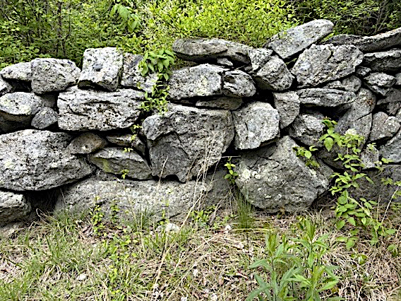

Jagged blocks of Avalonia granite hefted and stacked onto a single wall in in Stonington, CT. Only one tier is present and no courses. The largest stone at base is of the Assisted size category.

Flanking walls have only one face because they are built against an existing or excavated break in slope and are designed to help support that slope from gravitational failure and/or prevent surface erosion. To qualify as a wall, the higher stones must rest on, and be supported by lower stones, otherwise it would be a type of concentration, the veneer. The family Flanking wall leans into the slope, with a batter of at least several degrees, although soil creep can later rotate the wall outward to a vertical, if not overhanging slope where failure is imminent. The most common type of Flanking wall, the Retaining walls is near-vertical, and quite common on established farms, usually with a much stronger and wider base than top. The Normal retaining wall is the default, typically extending to or slightly above grade at the top. A Regolith retaining wall is one where soil creep built up against a freestanding wall, which now supports the break in slope. These I call "false retaining walls" because, though they act as retaining walls today, they were not built for that purpose.

Armoring walls, the counterpart to retaining walls, are very rare inland from the coast and away from rivers. In these cases, stone was placed not ON a near-vertical break between slopes, as with a retaining wall, but ON a non-near-vertical third slope segment, in such a way that the lower stones support the upper stones. The stack of coarse riprap to prevent beach or river erosion is an example of this type.

The family Enclosing Walls are associated with enclosures much smaller than fields and pastures. But discretion is required. A town pound or a small corral provide a perfect example. They are almost always uniform in construction technique, contemporaneous, strongly built (laid or stacked) of large stones (hefted or assisted) and present on three or four sides of an enclosure and need not have level tops. They were not built to hold stone along a fence line or mark a boundary but to deliberately enclose some small space. It's true that fieldstone walls in the back pasture may enclose a field at the end of the agricultural era, but they were originally not built to do so. Walls around a small cemetery almost always qualify as an enclosing wall. I differentiate a Square (type) enclosure from a Circular one. Square enclosures include pounds, cemeteries, corals, cisterns, and even the stone walls of a stone house. Circular enclosures include silos, kilns, charcoal rings pools, and round cisterns.

Supporting walls are those of foundations, cellars and elongated piers. They are defined by having a laid and horizontal top tier (flat enough to support a building sill) on two or more sides, so as to form a corner. Whereas an enclosing wall on a sloping surface typically has a uniform height, a supporting wall on a sloping surface must be higher on the downhill side. The cellar hole foundation is a perfect example. Because the foundations for buildings vary greatly in size, I arbitrarily differentiate the supporting walls of Small structures, like the cellar holes of houses, from those of Large structures, typically barns and large houses.

The family Blocking wall contains the stone wall that faces the downstream side of a mill dam, whose upstream side is filled with fine earth to block the flow of water. Except for its setting, this would qualify as a retaining wall because it has earth on one side, so this special category is needed. A mill dam is a Perpendicular blocking wall because it's built perpendicular to the stream it crosses. There are two kinds: the Dam or the Check Dam. The latter are uncommon barriers of large stones built across stream channels to slow the flow during floods. The dam may be Faced with stone, as with a typical mill dam, or it may literally be a Stone dam consisting of cut dimension stone. The latter are almost always for serious industrial purposes.

Blocking walls can be Parallel to the stream, instead of perpendicular to it. The purpose is to block water from accessing something. These parse out into Levees, which are near the stream and designed to keep it in the channel, and Dikes, which are away from the stream and designed to prevent something from being flooded. With the valleys of mill villages are all manner of stone-lined canals or raceways, which are too complex to include within the taxonomy.

Description

The description of walls is a separate step from their initial mapping, segmentation, measurement, and classification. Here I refer to the explicit description walls that rises above-and-beyond the implicit description contained with a designated kind (taxon) of wall. Consider the Lace Wall shown at the start of this manual. This taxon carries the implicit description that the stones form a single panel of a single wall are placed to create lots of pore space in the elevation (longitudinal, billboard) view. In other words, you can see through the wall, as with lace. What the taxon does not tell us, however, are many important things, such as the size, shape, composition, source, and arrangement of stones. Descriptions are optional and can range from cursory for the case of outback walls in a large population to monographic for the case of walls around an important historic site.

Remember that the basic nomenclature, the classification, and a protocol for measurement have already been described in previous separate sections. The organization of this section follows the Field Form, which was introduced earlier for segment labeling and classification. The screenshot figures below are not captioned. They are merely to point you toward sections of the Inventory Form Excel spreadsheet. Explanations follow the screenshots.

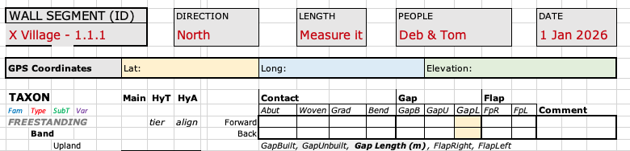

Now is time to make sure all segments and associated photos are properly labeled.

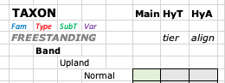

This was a "check-the-box" classification in green, described in an earlier section of this report. It also includes two gray boxes to check if you have a hybrid wall.

This was descried earlier. A minimum of three photos should be linked to the classification and to the heading.

This is a simple block to fill in. The goal is merely to note the presence of related features, which will be described on a separate form. Sample entries might be "nearby dug well" or "many piles, some banked against wall."

This section helps you quickly check the type of segment contact and the length of a gap, if present. If you are systematically working your way forward through multiple sections, you can fill in only the top row, labeled "Forward." If the section ends or begins with a gap, enter the length of the gap. The second row, labeled "Back" is redundant on the previous form, but is sometimes helpful to track because the segment description has both front and back. Though a gap is a kind of contact, and a flap is neither, this form condenses them to save space. The labels are abbreviations. A contact may be Abutting, Woven, Gradational, or defined by a Bend. A gap can be built (GapB), or unbuilt (GapU). A flap can be to the right (FpR) or left (FpL) in the direction of mapping.

At the bottom of the form is an optional box giving the opportunity to briefly describe why you decided to end the segment in the forward direction. You might say, for example, that the stone size increased abruptly, or that the shape changed.

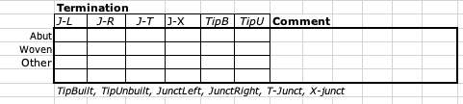

Remember that the initial and final segment of a wall is a termination, not a contact. This section allows you to quickly check the box about whether the termination is a junction (meets another wall) or a tip (ends unattached), and what kind of each it is. A J-L is when a wall junction corners left relative to the mapping direction, a J-R corners right, a J-T is ended by a crossing wall (as if crossing a T) and a J-X is when a wall ends with a cross-wall but continues as another wall further down the line of mapping.

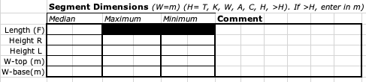

These were previously described under the section COORDINATES and MEASUREMENT. The length was previously recorded at the top of the from the map GPS coordinates. The first row, Length(F), provides a place to enter the measured length in meters (under median) as measured in the field, perhaps with a measuring tape or rangefinder (enter type in comments).

The rest of the measurements should be made for the median, maximum, and minimum estimated distances. W-top (m) is the measured width at the top in meters. Ditto for W-base at the bottom of the wall. Height R and Height L refer to the quick estimated height on the right and left sides of the segment using the average human ankle (A), knee (K), thigh (T), waist (W), chest (C), head (H) and higher than head (>H). If >H, measure and enter in meters. For an average male height, the equivalents in centimeters are Ankle (20), Knee (50), Thigh (75), Waist (100), Chest (140), Head )160) and > Head (>160).

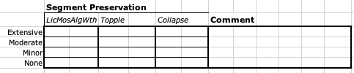

The Segment Preservation does not involve measurement and has previously been described. In this matrix of 12 boxes, you will likely check only 3 and possibly write a brief comment. The heading "LicMosAlgWth" refers to the overall surface appearance of the wall based on how extensive the cover is of lichens, moss, algae, and staining due to surface weathering, ranging from none to extensive. The gravitational failures are (a) from the top down, called a topple (tumble) and (b) from the bottom up, called a collapse. Here, the comment box will be helpful to describe the general "shape" the wall is in. I did not include "ivy" or vine coverage because it's ephemeral, but that can be easily added in comments.

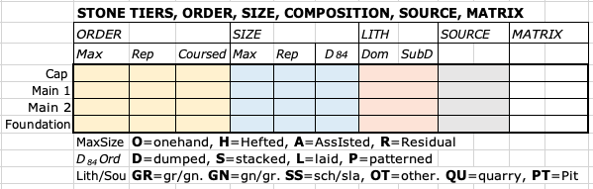

The most challenging box to fill in is the one titled STONE TIERS, ORDER, SIZE, COMPOSITION, SOURCE, MATRIX because it requires considerable estimation, discretion, and knowledge about thousands of stones for three or more tiers of the wall. These are also the most important clues to wall history and purpose. For example, a carefully laid wall is not mainly about waste disposal but architecture. And assisted stones lifted above grade in a main tier similarly point to architecture. Below the boxes are keys to the abbreviations to enter into the boxes. This section will be slow going at first but will quickly speed up as series of quick entries of letters in just a few boxes.

TIERS: To the left are the labels of rows for the vertical structure of the segment in tiers. These are the: Capping tier (Cap) if present, the foundation tier (Foundation) at the base if present, and the main tier (Main 1) which is always present. I added an extra row for a second, subordinate tier (Main 2) if present. If there is a third main tier that isn't a cap or foundation, be sure to add it as a line below the table and enter the abbreviations below the boxes.

The most common primitive single walls have only one tier, meaning only one row needs to be filled out across. It's a judgment call as to whether a foundation tier is present. A few assisted stones at the base does not constitute a tier. But a great many, especially if they are continuous, constitutes a foundation tier. Similarly, a few flat or decorative stones on the top of a wall does not constitute a capping tier.

SIZE: In blue are boxes for three sizes to be entered. You can record these as measurements if you like. But to simplify and speed up stone description I have categorized stone sizes down to these simple ones, as described earlier: O = one-handed, i.e., easily handled and placed on wall. H = hefted, meaning requiring 2-4 hands and no assistance from any device or livestock power. Usually, the upper limit is about 150 pounds, but this depends on shape. A = Assisted meaning some help other than the human frame. R - Residual. Technically, residual stones were not moved into a wall, but this category is retained because some walls are built over boulders large enough to meet that category. Knowing the exact size of a stone is interesting, but it isn't important for interpretation. The mechanical threshold sizes matter greatly. For example, as assisted stone raised above grade indicates that architecture beyond waste disposal is involved. It's helpful to know the maximum (Max), Representative (Rep), and the upper size limit for most stones (D₈₄ ) for all tiers. In most cases, the main tiers will be hefted (H) and the foundation tiers assisted (A). A laid wall is usually identified by chinking stones that do not support weight but fill spaces.

ORDER: See previous description of stone order. Briefly the degree of order in a wall segment indicates the care that went into its building, and thus its purpose. The presence or absence of a capping tier has already been noted. Ditto for whether the stones in a wall are coursed (as with brickwork). If you can see uniform layers, that tier is coursed. Just check the box. A capping tier is usually a single course of larger and more uniformly shaped stones, but a capping tier could consist of a vertical increment of uncoursed boulders. By definition, a coursed wall has a laid degree of order. Typically, large tablets and slabs are coursed, whereas blocks and balls are not. A multi-tiered wall is more ordered than a one-tiered wall.

For the bulk matrix of a segment these terms, defined earlier, apply: Dumped (D), Stacked (S), Laid (L), and Patterned (P). Some segments are laid in some places and not in others. Add this in comments. The form merely asks for the maximum ( Max) and the representative (Rep) degree of order, usually at the scale of a square meter or larger.

LITHOLOGY: A petrologist (rock scientist) could spend a lifetime classifying the compositions of a single wall. All we want to do is characterize the general composition with simple terms. To do this, I provide only the top three average regional categories for New England stones. Briefly,
- Granite is a light-colored, crystalline (individual mineral grains are visible) rock, usually without obvious metamorphic foliation (layering = banding) that produces mainly blocks of rock that round into boulders.
- Gneiss is a light to dark colored, crystalline rock with prominent mineral banding that typically produces sharp-edged slabs that round into pillow-shaped stones. Most gneisses in New England are similar to granite in composition.
- Schist is a variable-colored foliated crystalline rock with a strong grain (as with wood) but lacking conspicuous mineral banding, often with shiny broken surfaces, usually owing to a high mica and quartz content. It produces mainly flat tablets that round into disks when the corners are milled.

Walls often consist of a mixture of these three lithologies.

The goal is to decide which is dominant (Dom). In that column, enter one of these two-letter designations: GR = gr/gn for dominantly granite with some granite gneiss; GN = gn/gr for dominantly gneiss with some granite and schist; and SS = sch/sla for dominantly shist, with some gneiss and granite. Next decide which is subdominant (SubD), entering one of the three above.

Other lithologies are common in certain places in New England and may even be dominant. Marble is common in western New England from the Housatonic Valley to Lake Champlain. Basalt from lava flows, and sedimentary rock are common in the Connecticut River Valley. Slate is locally abundant. Quartzite is common here and there. If such lithologies are common, use the label OT = other and name them in the comment section. Also note the presence or absence of these if you can in the comment section.

SOURCE: Nearly all of the stone in all of the historic walls in new England is fieldstone. So, I don't require an entry for that default. Just leave it blank as assumed. The most common exception is QU = quarry when the stone was mined from a bedrock quarry. This is inferred when one or more of these criteria are met: there are tool marks on the stone such as drill holes or saw cuts; the stones are unusually flat-edged (not milled by moving glacial ice); or the compositions or shapes are different from the bulk of the wall. The exception PT = pit refers to stone excavated from unconsolidated material, like a sand pit, which is usually excavated for sand and gravel. The larger stones, left over, are often used in wall construction, usually after the age of steam and fossil fuels. These are often identified by their unusually smooth rounding and rust-brown staining.

MATRIX: The last column is for matrix, described earlier. Nearly ubiquitous is the drystone wall. Its matrix is simply air, so there is no need to enter anything. The most important exception is concrete mortar, which is often applied to the capstone tier to strengthen it and prevent theft, but mortar is also applied to the main tier on the face of the wall. I did not provide abbreviations because there was no room, so just enter a C for concrete if present. Also possible for buried and submerged walls are a S = soil and W = water matrix. These are too rare to worry about. Use the comments.

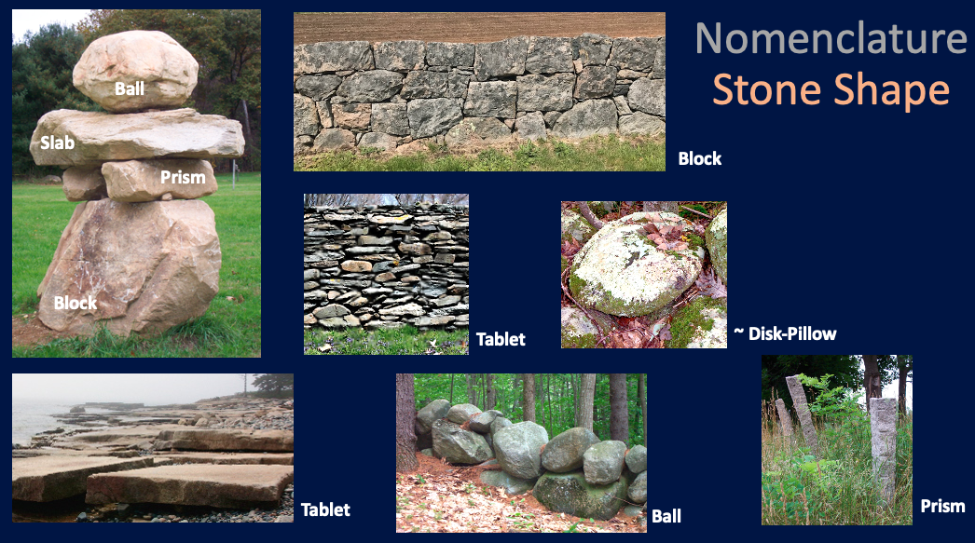

Examples of stone shapes. See the Table 1 in TAN - Nomenclature for ratio thresholds.

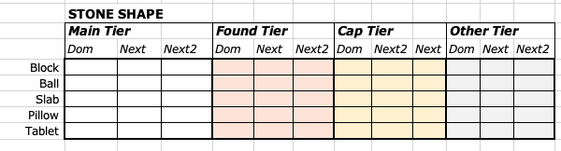

SHAPE: The final block to be entered involves stone shape. The full list of stone shapes is in the nomenclature section, or Table 1 of TAN. Blades, which round to dull blades, prisms, which round to columns are very rare. They are not on the list but mention them in the space below if common. Nor did I include the shape disk, which is a rounded tablet, for the reason that they are not common. When in the glacial grip tablets tend to break before their corners round. I include only blocks which round to balls, slabs which round to pillows, and tablets.

The entry table asks that you characterize the general shapes of stones within the Main (always present), Foundation (if present), and Capping (if present) tiers by identifying the dominant (Dom) and next-most dominant (Next). This is usually sufficient. If a third shape is common, use the Next2 box for that tier. Capping tiers commonly have only slabs or tablets. Foundation tiers often have only blocks, slabs, balls, and pillows.

Features

Features within the stone domain, but not in the class Wall, require a separate Field Form This inventory entry form is for Lines, Concentrations, and Notable Stones. It can also be used for any feature linked to an inventory of the stone domain. It is much more general, because features include a wide variety of phenomenon from isolated piles to tall stone towers, and a data entry form to include them all would be too cumbersome.



The Feature Entry form is far less complex than the Wall Entry Form. It opens with the heading above. Features, seen as complements to Walls, need not be numbered in any special way. I suggest identifying them sequentially by number. In this case I refer to Feature 1a, connoting a multi-part feature, like a group of piles. In other circumstances, each pile could be a separate feature. This is a judgment call.



The base of the form includes a box to remind you to take documentary photographs, describing them here.

Taxonomy

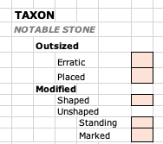

The next level down on the Features Entry Form includes an orange box to check the Taxon (as for stone walls.

As with the previous section on stone walls, the Taxon of a feature emerges through use of the classification in the Excel Spreadsheet SWI Inventory-TAXONOMY-Table 2 TAN. This form includes a short version of this for quick checking the box. To end up on this page, the object failed one or more of the criteria for defining a stone wall: Material, Granularity, Continuity, Elongation, and Height.

The class Line easy to identify. They are elongated stone features that would be walls except for the fact that they are either not continuous, not high enough, or both. Low lines fail the height requirement, and either Border or Divide an area. They range from a line of cobbles to a flagstone path. High lines meet the height requirement for a wall but fails the continuity criteria. There are gaps between the stones. These I divide into Dotted when the average spacing between the stones is longer than the average stone diameter, and Dashed when vice versa.

The class Concentration fails either the elongation criteria or the height criteria or both. They may be the family Built with a stacked, laid, or patterned degree of order or Dumped (unbuilt).

Built concentrations are either Surfaces or Uprights. Surfaces are either Pavements if laid flat on the ground like a stone patio or cobblestone street, or Veneers if they slope steeply on a bank, usually placed to stabilize a slope and prevent erosion, as with a sloping riverbank or roadcut. Uprights are either Detached if they are solitary, as with a trail-side cairn, or Grouped, as with the piers of an abandoned bridge.

Dumped concentrations are abundant in some areas because the dumping of piles in in fields was a common early step in the land improvement process. The most primitive concentration is the Scatter. Stones were pitched near one another, but not to the point where they were all touching, as with a pile. This would have been a very early step, for example the prelude to a pile, or the first stones pitched near the base of a fence. A Fill is an easy taxon to identify. It's a pile in a depression whose top does not rise above local grade. In contrast, a Pile is above grade. By far, the most common pile is the Normal subtype. It is a mound of dumped stone of any non-elongated shape. If it reaches or exceeds a length/width ratio of four, it becomes a stone band, the most primitive type of freestanding wall. Attached piles are those in contact with stone walls, usually as a Corner pile, and less commonly along any segment to form a Segment pile. Aligned piles, with three or more piles along the same line, are often the prelude to a stone band or built uprights. The final subtype of piles are Ring piles, which come in a variety of sizes. Arbitrarily I divide these into Large, typically those tossed around the base of a charcoal kiln, or around tree or stump that later rotted. Alternatively, they may be stacked to bank a campfire. Small, ring piles are those that formerly surrounded a fencepost and consisting of the stones excavated for it. When such piles are aligned, they indicate a former fence line.

Concentrations include the evocative chambers, many of which are historically authenticated food storage places, using the thermal inertia of stone and soil to keep things cool in the summer and above freezing in the winter. Many are also claimed in the general category known as a ceremonial stone landscape (CSL) of indigenous origin.

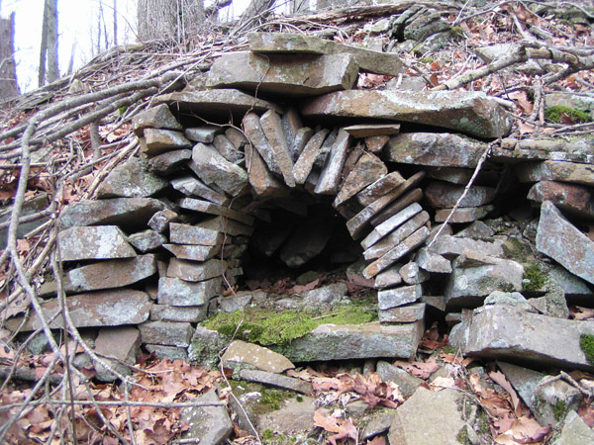

Stone feature described by text below. Credit: Someone gave me permission to share this photo, but I lost track of source and place. If this is your photo, please let me know. A chamber of unknown origin shown below was carefully built into a hillside.

We can classify the above feature as an upright built concentration. It's in the class concentration because it's not a wall, line, or notable stone It's the family Built concentration because the degree of order is stacked or higher. It's the type Upright built concentration because it has a height greater than one stone thick, and finally, of the subtype Detached upright built concentration because it's not connected to another feature like a set of pillars to support something. Widely spaced cairns are also considered detached.

We can use our nomenclature and previous experience with stone walls to describe this feature further. A large tablet of stone of unknown composition forms the base of an arch built primarily of carefully laid slab and tablet shaped stones. In turn, this inner arch supports a stacked arch (laid at the top) of larger slabs. The inner portion of the chamber seems to have been faced with one-handers which are now collapsed on the floor. The rear of the chamber extends into the hillside, as evidenced by the localized growth of moss.

The class Notable Stone fails the granularity requirement, because the focus is on an individual stone, rather than a collection of them. A notable stone is notable for one of two reasons: it is much larger than in the general terrain (Outsized) or it has been altered in some way (Modified). Most outsized notable stones are glacial erratics that have not been moved (Erratics). However, with the advent of petroleum, many large stones that would qualify based on size, have been moved and placed for architectural purposes (Placed). The alternative to an outsized notable stone is a modified one. It can be modified by being shaped in some way (Shaped) as with a stone post or obelisk, or gravestone, or any carved stone, or in its original shape (Unshaped). If shaped, it usually has markings, as with carvings or quarry marks. If unshaped and otherwise unmodified, it can be erected as a Standing Stone. Alternatively, in a stable configuration with respect to the center of gravity (Stable), it may be marked in some way or perhaps bear a plaque.

In our trial inventories, we have found it effective to mention features on the Wall Entry Form, and then return later to describe them on a separate visit using the Feature Entry Form. Wall inventory requires a stepwise application of defining segment contacts, segments, walls, wall terminations, and parcels. Features, being more widely dispersed and variable in structure, requires more flexibility.

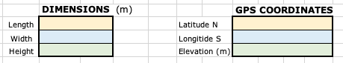

Opposite the taxonomy is box to record the basic Dimensions of Length, Width, and Height; and the GPS Coordinates. The entry is wide in case more than one set of coordinates is needed. If this were a stone pile, it would have obvious dimensions and a single XYZ coordinate.

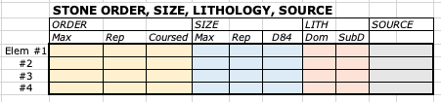

This is modified form the box for stone walls. Instead of tiers, we assume different elements of a feature, which can be named and described separately. I removed the category for matrix to fit it on the page. This can be added to the right of SOURCE or in the comments section.

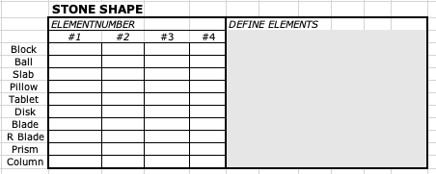

Here, I include all of the standard shapes because sometimes a stone is notable for its shape. Standing stones or dolmens and typically blades or prisms, both of which have a much longer length (a-axis) than the other two.

Dating & Chronology

Chronology is arguably the most challenging aspect of stone wall science because it cannot be seen or measured in the field directly visual or measurable. Below are several ways to determine the age of a stone and the descriptions of general age categories.

Rule of Thumb - Deforestation

In general, the date of rural farm wall construction follows the more widely known date of deforestation, which was recorded at the town scale as "improved" land. for tax purposes. Typically, local wall construction lags local land deforestation by a generation because it took time for the stone to accumulate on the surface and be scuttled sideways to property boundaries and fences. This data has been generalized to the state level by Harvard Forest. See first figure below.

Key observations include:
- Population has an exponential rising path, whereas deforestation is a wave followed by recovery prior to suburban sprawl beginning in the 1960s.
- Nearly every state was nearly equally forested (90%) prior to Euro-settlement.
- Deforestation peaked in the decade 1850-1860.
- Except for the smallest and southernmost state of Rhode Island, deforestation was slow from 1600 to the birth of the New Republic (1783-1787), after which the rate increased dramatically to peak deforestation between 1830 and 1850.
- Re-forestation was more unform state by state than deforestation. Maine is anomalous because it's huge area masks intense settlement in the southern counties. Rhode Island is anomalous in having much earlier and steady deforestation prior to the peak.

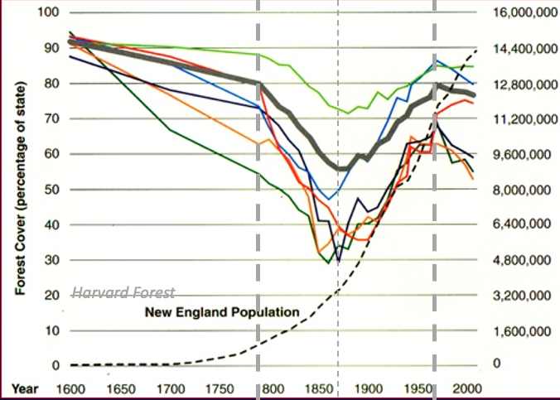

Graphical chronology (bottom scale) of New England deforestation (left scale) and population growth (right scale). Wide dark band is the regional average. States are from the bottom up: Rhode Island (dark green), Connecticut (orange). Massachusetts (dark blue), New Hampshire (blue), Vermont (red), and Maine (light green). See text for details.

Calendar Ages

In the rarest of cases, a wall can be directly dated by linking a written, dated, archive document to a particular wall. For example, a far ledger account book might explicitly state that some portion of the "north" wall of a certain farm was being built on a particular date.

The maximum age (wall is younger than the date given) for a farmstead wall, for example, 1730, may be provided by:
- The date of town settlement, the incorporation of the town, the gathering of a local church congregation. Walls on land in this vicinity are probably younger than any of those dates.
- Tax records often describe the proportion of "improved" (=deforested) land on a property. If there is no improved land, there are no cleared fields, and thus no walls. Carrying this forward in time the percent of a farmer's improved land tracks the abundance of walls by at least a decade because it takes times for stones to accumulate.
- Land records such as a surveyor’s map might use a wall as a "bound" of edge of a property, mentioning this in the deed. The wall predates the survey.
- Account books for the sale of agricultural products (livestock, butter, cheese, grain, milk, etc.) indicate the presence of animals on the land, which usually correlates with the building of walls.
- The presence of walls described in documents or shown in illustrations.

A minimum limiting age (wall is older than the date given)
- Land or tax records indicating sale of property, abandonment or the discontinuation of agriculture.

Owing to all these complexities, I suggest that you work at the level of individual properties, tracking land and tax records. Working with a professional historian or surveyor is often warranted to refine working ages.

Age Expectations

Indigenous - Humans were living in North America since at least 20,000 years ago, when the Laurentide Ice Sheet was beginning to recede from New England. Some aspects of the stone domain (piles, rings, notable stones, short sections of stacked stone) were part of indigenous material culture as dolmens and cairns. The trick is to differentiate these "needles" in a haystack from the "hay" of the nearly ubiquitous Euro-settlement overprint.

Colonial - New England walls built by European settlers range begin with the year 1607 from the Popham colony in south-coastal Maine. In later coastal settlements the earliest stone features date to the year of arrival in the first half of the 17th century because primitive wharves and piers and sea walls were essential. The famous erratic known as Plymouth rock, dating to 1620, is a notable stone, in this case an erratic that was moved and imprisoned below the modern wharf. Features on rural New England properties inland from the sea are typically younger than Metacom's war of 1675-1676 and are restricted to major settlement pathways like the Connecticut River Valley. The Concord River Valley, MA, dating to 1635, is a notable exception.

New Republic - Generalizing for all of New England, and rounding off to the nearest quarter century, the peak of wall construction occurred during the half-century of the New Republic of the United States between the onset of the American Revolution in 1775 and the opening of the Erie Canal in 1825, with northern and interior towns lagging those closer to transportation corridors. Adding a quarter century on either side of this range brings us to the century 1750-1850. My guess is that three fourths of wall length dates to this mainly post-colonial century. Walls of this century predate the collapse of agriculture in mid- to late-19th century were usually built as a farm chore by people from the farm being fed by the family farm economy. Thus, they typically have no dates assigned to them because they grew piecemeal through the generations. The best dates are usually bracketing dates between the year of town establishment (always known) and the decades when wholescale abandonment was underway (available from census data). The problem with this technique is that region-wide and statewide generalizations are dangerous. One farm could have been expanding when others were being abandoned.

Gilded Age - Walls post-dating the American Civil War, especially those from the industrial Gilded Age are more likely to have written documentation of construction dates than farm walls because they were effectively construction projects associated with hired work crews and written invoices, usually associated with country estates and second homes. The same is true for professional masonry today.

Modern Walls - These are technically not part of the Stone Domain because, not being historic, they do not meet the criteria of "historic material culture." However, they can easily be included in any inventory.

Agricultural Stages

My earlier book Exploring Stone Walls offered a floating chronology based not on calendar years, but on the stage of the farm establishment. These broad generalizations provided convenient labels for linking features from the stone domain to a certain stage. Consult that book for a more involved explanation.

Pioneering - The early stage involved early land clearing, the building of a house and the movement of stone as either waste or resource. Piles, bands, and triangular single walls are dominant, and highly variable in style. The driving force was the human ecology of waste disposal, rather than architecture.

Established Farm - With much of the land cleared, and with larger families, the stage finally arrived when slack time could be devoted to improving the look of the land. Many piles were moved to field edges. Double walls, broad wall, panel single walls, and rebuilt walls are common.

Forest and City - After farm abandonment, most remote properties were left to decay and become reforested and the walls to begin to fall apart. Simultaneously, well-off residents of increasingly crowded cities were obtaining country properties. Using money coming from commerce and industry, rather than farming, they hired crews to rebuild many walls, including capped double walls and patterned walls.

Reclamation -- The final stage dates from approximately the mid 20th century rise of the conservation and environmental movements, and the increasing wealth of suburban and ruburban (contraction of rural and suburban) residents. Many homeowners and landowners began repairing and restoring the old stone walls that had been abandoned a century earlier, or hiring masons to do the same.

Concepts & Techniques

Relict vs Historical - Merriam-Webster defines the adjective "historic" as "famous or important in history." Very few England walls reach that bar, though the entire phenomenon does. They define the adjective (the noun form is relic)"relict," as "a thing which has survived from and earlier period or in a primitive form." Nearly all of New England walls easily meet this definition.

Multiple Ages - Most walls have multiple ages; many modern walls were rebuilt in whole or in part, making each wall a combination of ages (a palimpsest of ages).

Weathering & Organic Change - A new wall built of freshly quarried stone is easy to recognize because the local dryland ecosystem has not yet had time to weather the wall to the grayer colors of a sun-bleached or surface-weathered wall, and because all of the stones are in place. Nor has there been time to cloak the stone with lichens, algae, moss, and microbial biofilms. Walls that are merely decades old still "look" on the young side because these processes of weathering, colonization, and disintegration, have not yet reached completion. But after a century or so, the age of walls becomes very difficult to differentiate because the "look" is due more to forest history than age.

Tool Marks - Drill holes for quarrying and stone splitting, have diagnostic dimensions and terminations that can differentiate hand-cutting of stone using pin-and-feather techniques from percussive air drilling, which generally dates to the mid 19th century.

Chronometric Techniques - Walls older than a century are notoriously difficult to date as objects using archaeological techniques. Lichen dating, which works well in the Arctic, fails in the moist, closed-canopy forests of New England. Radiocarbon dating is limited by the fact that stones to not take in carbon that might decay. Carbon pathways associated with their construction and decay are notoriously complex. The best technique for dating the placement of stone structures comes from luminescence dating of the soil (sediment) on which stones were placed, thereby providing a maximum age for its last exposure to sunlight. A recent review (see Background) concluded that these derived ages typically occurred in the 16th century, a century before the widespread Euro-settlement, but likely associated with it. Rare earlier exceptions date indigenous stonework.

Cross-cutting relationships - If a wall crosses an object of known age, for example an old indigenous trail, it is younger than that object, and vice versa. I once convincingly dated a wall that was alleged to be from the early 19th century by discovering that a mangled Ford hubcap from the 1950s was supporting the overlying tier of stones.

Inclusions - If a wall contains an object, it is younger than the objects it contains. For example, the stones are younger than the wall. Broken porcelain or brick is used as the hearting for a double wall, the wall is younger than the material of the hearting. Old bottles with the metal caps rusted off are frequently found in the interstices of walls, which likely predates the bottle.

Imagery - Old paintings can't be trusted to date a wall because the artist can ignore them when present or paint them in when not. In contrast, graphic artists, such as Jonathan Warner Barber worked hard to sketch the scenes as they saw them (see image below). Historic photography is direct evidence of the presence of walls, for example the 1880s view of Block Island shown on the cover of this manual.

Management Ages - Drawn from my 2024 article in Public History, this includes (1) Pre-Euro - Anything older than colonial settlement in the early 17th century. (2) Relict - Features associated with the initial and widespread settlement, deforestation, and re-forestation before the low point of town census populations, ranging from the 1830s to the 1930s. (3) Later - This category is the opposite of relict because post-agricultural walls were still being used and built, mainly during the age of easy automobile transport. and (4) Recent - These are the newer walls associated with modern real estate development and wall builders.. If not historic, they are not part of the stone domain.

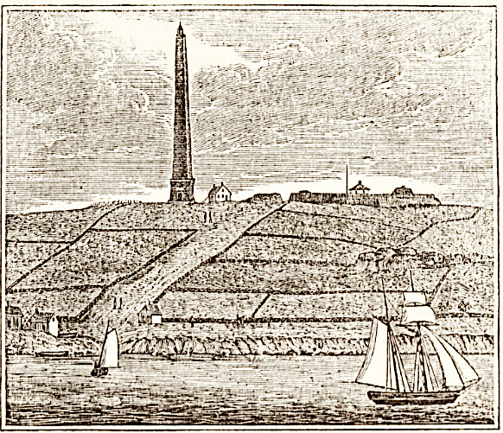

Engraving of Groton Monument and Fort Griswold, Groton CT published in 1836 by John Warner Barber's Connecticut Historical Collections prove that the individual walls shown here predate the engraving. Coastal communities were denuded earlier and thus the walls are earlier. Earlier images would sequence the accumulation of walls.

Petroleum Walls - The advent of powerful, petroleum-powered equipment changed the nature of stone walls in New England: Bulldozers beginning in the late 1920s were able to push through walls to create gaps and flaps. Front end loaders arrived in the 1930s, and backhoes in the 1940s. Former residual stones (too large to move) were lifted into walls. My short-hand term for walls with these formerly oversized stones are "petroleum walls."

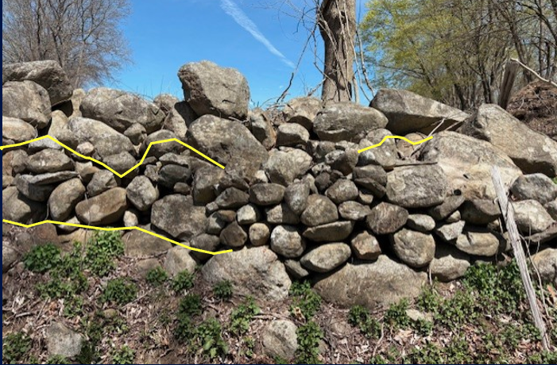

Three-tiered wall in Hampton, CT with tiers separated by yellow lines. It consists of a: basal tier of foundation stones dragged to become the base of an old farmstead wall; main tier of stacked, hefted stone hauled and stacked by hand; and a top tier of what I call "petroleum stones" lifted and hauled since the 20th century by powerful equipment. Barbed wire is crushed by the top tier to indicate a wall history with four stages.

Catalog & Data Entry

The end result of all that ground-truthing, segmentation, measurement, classification, and description is a catalog, which consists of data and information for each unique segment. This is comparable to that of other professionally cataloged records, for example a library has a catalog of its holdings, as does an art museum. At some point this catalog will be entered into your ArcGIS system so you can see the spatial variation in attributes such as wall type, dimension, or assigned age. How you go about this is very open ended.

For one of our preliminary studies, I built one using an Excel Spreadsheet that is merely a compilation of the Data Entry Forms. I do not share this as an Excel file because it's too premature. Instead, I show it as a pair of overlapping screenshots too wide to fit one page that overlap on the yellow column "Dimensions." The column headings are mostly hierarchical and self-evident.

This catalog, this spreadsheet, was then entered into ARC-GIS software as attributes. For data management experts, much of this can be automated.

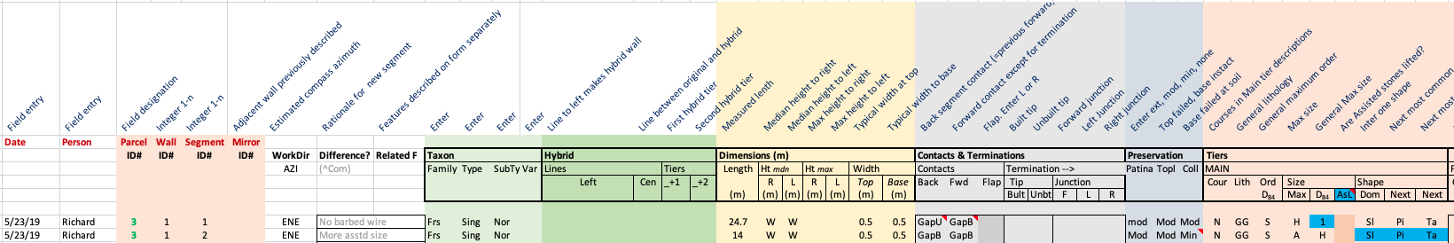

Screenshot showing all column headers for the data entry table that served as a catalog for our first field trial of a stone wall inventory. Explanations of the headers are in dark blue diagonal text. From this point onward, the catalog was entered into ArcGIS. There is no entry for chronology. The three illustrations below are overlapping screenshots showing enlargements in sequence. See text for explanation of terms.

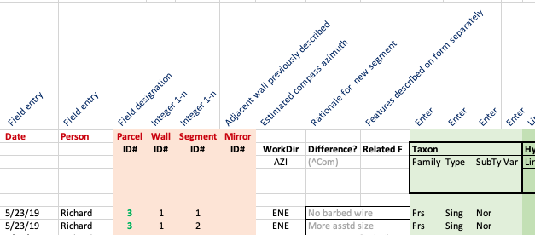

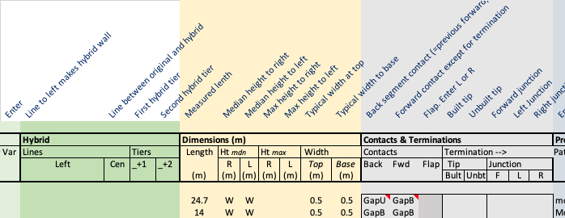

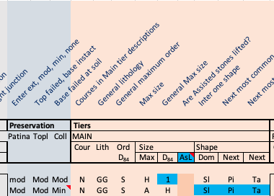

Analysis & Interpretation

Stone wall science is in its infancy. This manual was written for field inventory, not for analysis. A separate manual could be written for the ArcGIS mapping and statistical analysis of that field inventory. Until then, I opt to end this manual with preliminary results of our 2019 inventory of walls of the Goss Brook Village in Ashford Connecticut used earlier as an example for naming protocols.

This was part of one of three areas analyzed my Johnson and Ouimet (2016). We (William Ouimet, our student Richard Manandhar, and I) returned in 2019 to field test the protocol for a field inventory, work presented published as an abstract at the 56th Annual Meeting of the Northeastern Section of the Geological Society of America in 2021 in Hartford, CT. In 2023, this was revised and updated, mainly by as Stop 1 of the June 2023 Annual Field Trip for the Connecticut Geological Society, the source of all images.

The purpose here is to show you how GIS systems can map segments and walls by color coding them, and how that mapping can aid with interpretation.

This manual is not the place to replicate our preliminary mapping and interpretation. Rather, we merely point out a few interesting trends and patterns to show how much more information there is in an inventory (census/catalog) than from LiDAR mapped lines.

I start with the simplest variable to map, HEIGHT, then move on to ORDER, and end with TAXON. After making interpretations from separate variables, I combine them.

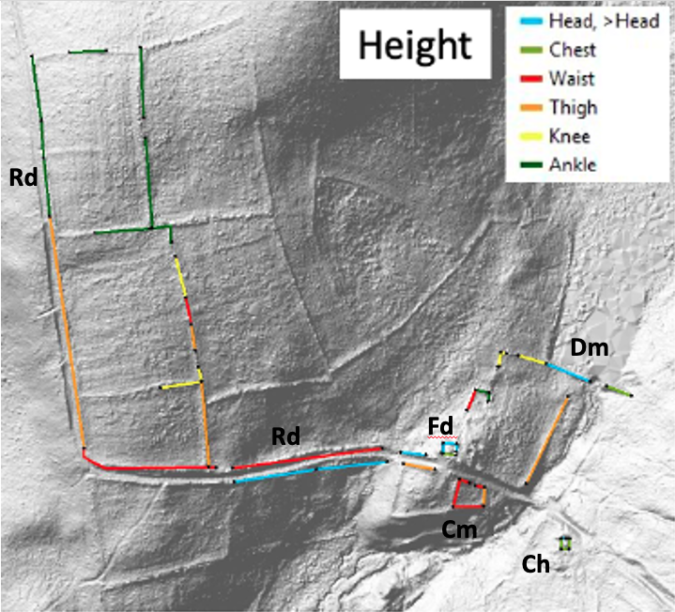

Preliminary map of Goss Brook project area in Ashford CT showing the attribute SEGMENT HEIGHT identified by color (see map legend in corner). Segments are bounded by black dots. Only those segments with colors were inventoried. Compare with other maps of the same area for SEGMENT ORDER and SEGMENT TAXON, which contains a graphic scale. Abbreviations include: Rd=Road, Dm=Dam (stone faced), Fd=Foundation large (likely for barn), Cm=Cemetery (village), and Ch=Cellar Hole. These features are unlabeled on subsequent images.

- The height of walls is highly variable, ranging from greater than head high to ankle high.
- There is no standard height: waist-, thigh-, and ankle-high walls are co-dominant. Surprisingly, knew-high walls are not very common, and head-high walls occur only in unusual situations.
- Note how the exterior roadside wall to left contains only two segments, whereas the single wall just left of center has six segments and a long gap. This suggests an early hoc field clearing in the center, and a later and more focused construction project for the roadside wall.
- The highest wall is for the stone-faced dam. It's well over head high fronting the now filled swampy reservoir, chest high along its extension to the other valley wall to the east and is missing between these segments where it was washed out during a flood.
- High walls also occur on the inside of the building foundation and along the downhill side of the retaining wall supporting the road where the slope is the steepest.
- Walls are lowest in the furthest field away from the village, merely ankle high stone bands and low single walls.
- The roadside wall to the west drops from chest-high to ankle-high near the corner of the furthest field parcel. This suggests a subsequent extension.

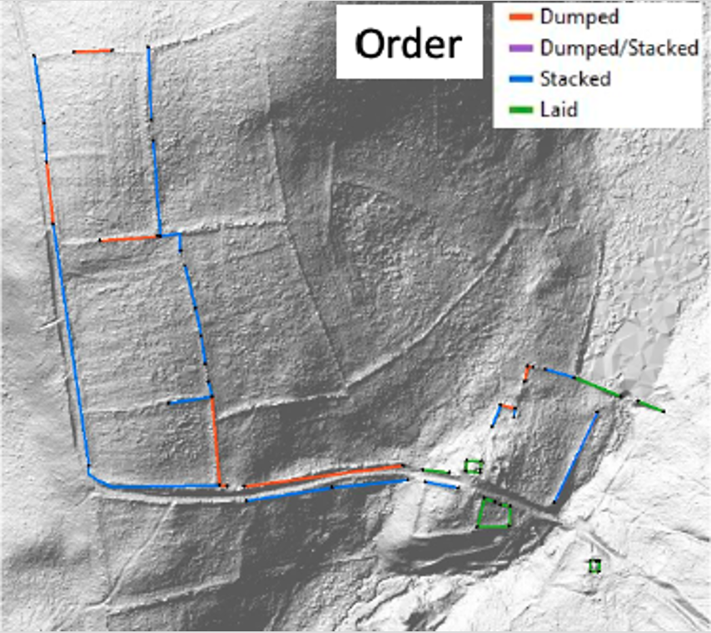

Map of the degree of order for stone walls in the Goss Brook district. See text below for interpretation.

A few observations:
- Stacked walls are most common. Stacking is only slightly more effort than dumping and pays off handsomely by creating a more visible line and a higher fence.
- There is an abrupt dichotomy in the degree of order between field walls away from the village center. Field walls are mostly stacked with some dumped. In contrast, those near the village road, mill, dam, and buildings are all laid. We found no patterned walls.
- Dumped walls are always on field edges.

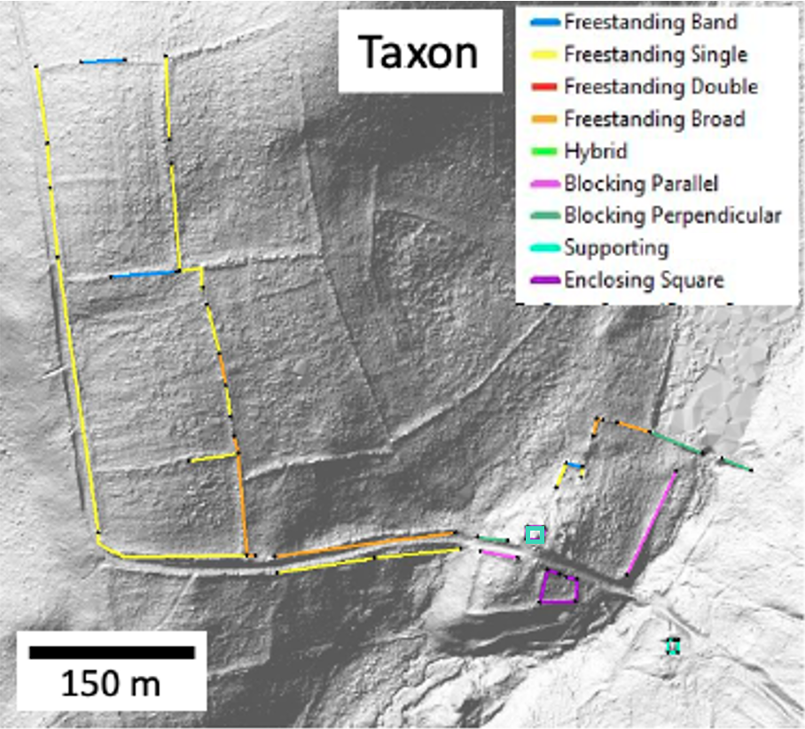

The classification of stone walls near Goss Brook, Ashford. The supporting wall opposite the Enclosing Square (cemetery) is a large foundation.

Some salient observations.
- We found no double walls, which are very common elsewhere, especially in districts where the walls were rebuilt after the Civil War. This was a surprise.
- What we found instead were abundant broad walls, which are essentially extra-wide double walls. This suggests that stone disposal, rather than architectural beauty was the dominant purpose.
- There was a great range of wall types from primitive bands of waste stone along former fencelines to the carefully laid face of a mill dam greater than head high (perpendicular blocking).

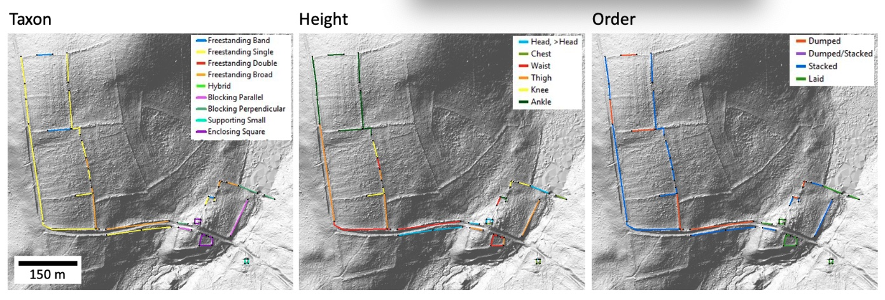

Previous Three attributes of walls seen in the same view. A sample observation is that yellow (single walls) and blue (stacked) usually coincide. Another is that taller walls have higher order.

Matching colors in your mind, we can think about how these three variables work together. Below are just three examples.

- Single walls are stacked, rather than laid, and are most commonly thigh high. This three-variable consistency suggests a farm effort for which stone disposal was the main objective. Legal fencing was reached using wood (or later wire) above the stone.
- The cemetery wall here provided a perfect example of a squared enclosing wall built as a capital project, probably with stones from the immediate vicinity, which lacks walls. It is higher than most (waist), uniformly well laid, gapped with an opening gate. Though classified as squared, it is trapezoidal in shape.
- For any given shape and size, laid walls are stronger than other orders because the particles (stones) are more tightly fit together. Thus, this makes sense for a cemetery enclosure, a mill dam, and building foundations.

For this project, we have completed the descriptions on the field forms, but we have not yet analyzed them. For now. For now, we provide only four parcel and segment descriptions. These were investigated during reconnaissance by Robert M. Thorson and Richard Manandhar, with data entry by Manandhar in late July 2019. These are one-paragraph summaries drawn from the segment Field Forms. For now, we have not included other features within the Stone Domain (Lines, Concentrations, Notable Stones) and features from without, for example canals, earthen mounds, ditches, and more complicated phenomena.

Typical field/roadside wall. Segment P36W6S1 is a Normal (Subtype) Single (Type) Freestanding (family) wall with inline junctions and no gaps. Its length is 177.4 m, height is asymmetric (thigh-high to west on road and knee-high to east pasture) with a trapezoid cross section (basal and top width of 0.8 and 0.6 m and is moderately preserved with a well-developed surface (patina/lichen/moss/rind), and with moderately common topples and collapses. The wall is un-tiered and uncoursed with slabs (angular), pillows (rounded slabs), and balls (rounded) of granite gneiss (GG) with a maximum and D84 size of hefted stones and built with a stacked degree of order. All of these attributes suggest an archetype, early-stage clearing and fencing. The length and uniformity suggest a project roadside upgrade rather than piecemeal accumulation.

Cemetery. This is a four-sided cemetery enclosure immediately south of the road with two segments on the northern (entry) side (P38W1S1 east of entry, P38W1S2 west of entry). The remaining three walls are single segments (P38W2S1 to east, P38W3S1 to south, and P38W4S1 to west). The taxon is named for the small enclosure as a set of Square (type) Enclosing (family) walls (class). Within the enclosure are gravestones, which are Shaped (type) Modified (family) Notable stones (class). The top tier is NOT horizontal (as with supporting walls), exhibits the laid degree of order, and is waist high on three sides, which is most typical of deliberately built small enclosures.

Mill Dam. The mill dam is the third segment (P41W1S4) of a four-segment continuous wall extending West-northwest to East-southeast across the brook, with earthen fill and the impoundment to the north and a clean stone face to the south. The Taxon is Dam (subtype) Perpendicular (type) and Blocking (family). For dimensions, it is 26 meters long with stone exposed for a vertical height of 1.6 m high. The segment is 1 m wide from top to exposed base. The main tier consists of slabs > blocks > pillows of hefted Granite Gneiss with a carefully laid degree of order. The capstone tier is entirely slabs arranged as a double wall.

Cellar Hole. The cellar hole consists of four walls surrounding a collapsed cellar later capped with concrete: East (P37W1S1 and P37W1S2), South (P37W2S1), West (P37W3S1) and North (P37W4S1). All five segments are built alike indicating simultaneity with a carefully laid, horizontal capstone tier consisting entirely of hefted slabs of gneiss and schist with no other shapes. Some of the slabs are elongated, suggestive of shaping. The taxon is Small (type) Supporting (family). The main length (Wall 2) is 10 m long. The northern equivalent Wall 1 has segment 1 at 7 m long and segment 1 at 1.4 m. The height is chest high on all sides. An associated feature is a rock pile in the center.

These summaries provide an example of only the beginning of an analysis. The final interpretations of your specific districts will become a story, or independent history, told by phenomena seen on the ground, rather than in written documents.

Recommendation

This manual contains step-by-step instructions for conducting an inventory (census) of stone walls on a piece of land in New England using a standardized procedure. My recommendation is for you to decide the scope of your inventory as warranted and affordable in your case. The key idea is to get the project started with some sort of mapping, and then let the descriptions and interpretations of those mapped attributes grow through time as opportunity, funding, volunteers, and expertise becomes available. Then, at some future point, perhaps years from now, the analysis of your results will provide useful information for the management, conservation, and investigation of stone walls on land you care about.

I also recommend that you intermittently visit the Stone Wall Initiative web page for updates of this manual and the related blog.

Good luck!

